**UNIVEN reflects on its achievements over the past four decades**

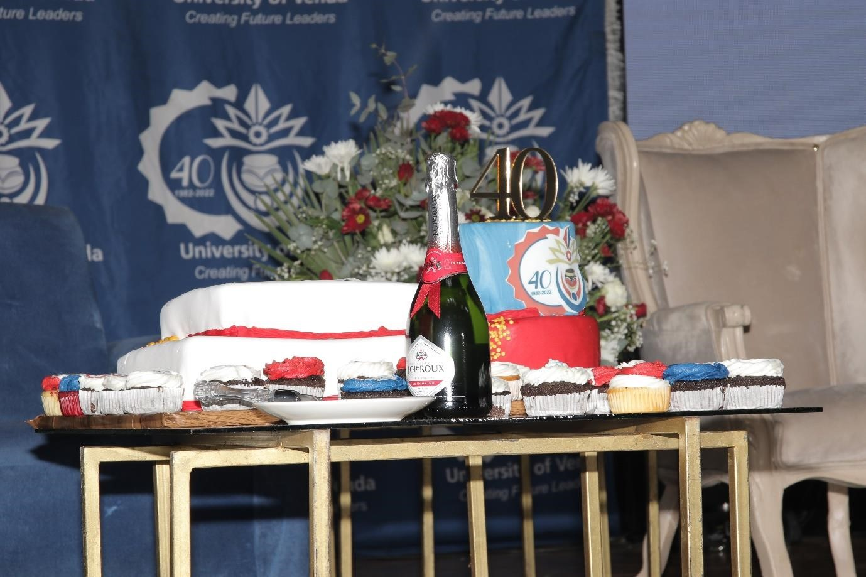

*The photo above: UNIVEN 40th Anniversary Celebration cake*

The University of Venda (UNIVEN) opened its doors in 1982 on the grounds of the Dimani Agricultural High School in the Tshivhase territory. Over the past 40 years of its existence, UNIVEN has seen tremendous transformation and growth at an extremely fast pace. On Thursday 27 October 2022, UNIVEN celebrated its 40th Anniversary of serving local and international communities by shaping future generations. This hybrid 40th Anniversary celebration was held at the University Auditorium under the theme ‘R*eflection on the University’s achievements over the past four decades*.

Recent University rankings by Times Higher Education World University Rankings show that UNIVEN is among the top 15 best universities in the country. This significant growth is one of the greatest achievements ever attained by the University of Venda since its establishment in 1982.



*A toast for another successful upcoming 40 years and more*

The celebration was characterised by embracing past achievements, recognising success stories, and helping to shape the future.

The event was amongst others attended by former Vice-Chancellors, Chairpersons of the Council, former SRC Presidents, alumni, friends, and partners of the University both local and international, Traditional and Religious Leaders including staff and students, as well as retired staff members of the University.

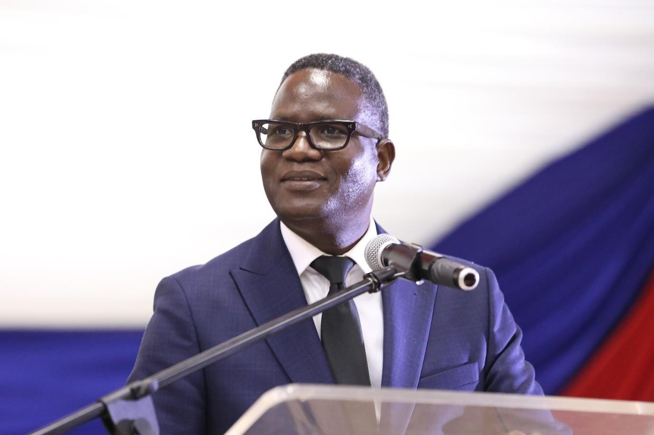

When outlining the evolution of the University of Venda during the 40th-Anniversary celebration event, the Vice-Chancellor and Principal, Dr. Bernard Nthambeleni indicated that UNIVEN started with only 177 students, and today it has an enrolment of more than 15 000 students. He said in the past 40 years, UNIVEN has created a vibrant space that produced and still produces well-rounded graduates who compete locally and internationally. These are graduates that are holding important positions locally and internationally both in the public and private sectors.

“Anniversaries are opportune moments to take stock of the road traversed, to reflect on the decisions made and the detours we have taken during our journey. They are also an opportunity to pay tribute to those that have laid the foundation of our journey and eased our burdens and lifted our spirits along the way. It is also a moment to celebrate the milestones achieved and reflect on the hurdles ahead”.

“As we celebrate this 40th Anniversary, it is befitting to pay homage to our forerunners who shared a vision for an educated nation, for without their foresight, there would be the no University of Venda to speak of. The challenge ahead of us is to do more and better than what we have done so far. Our path is upward and there is no room for regression”.

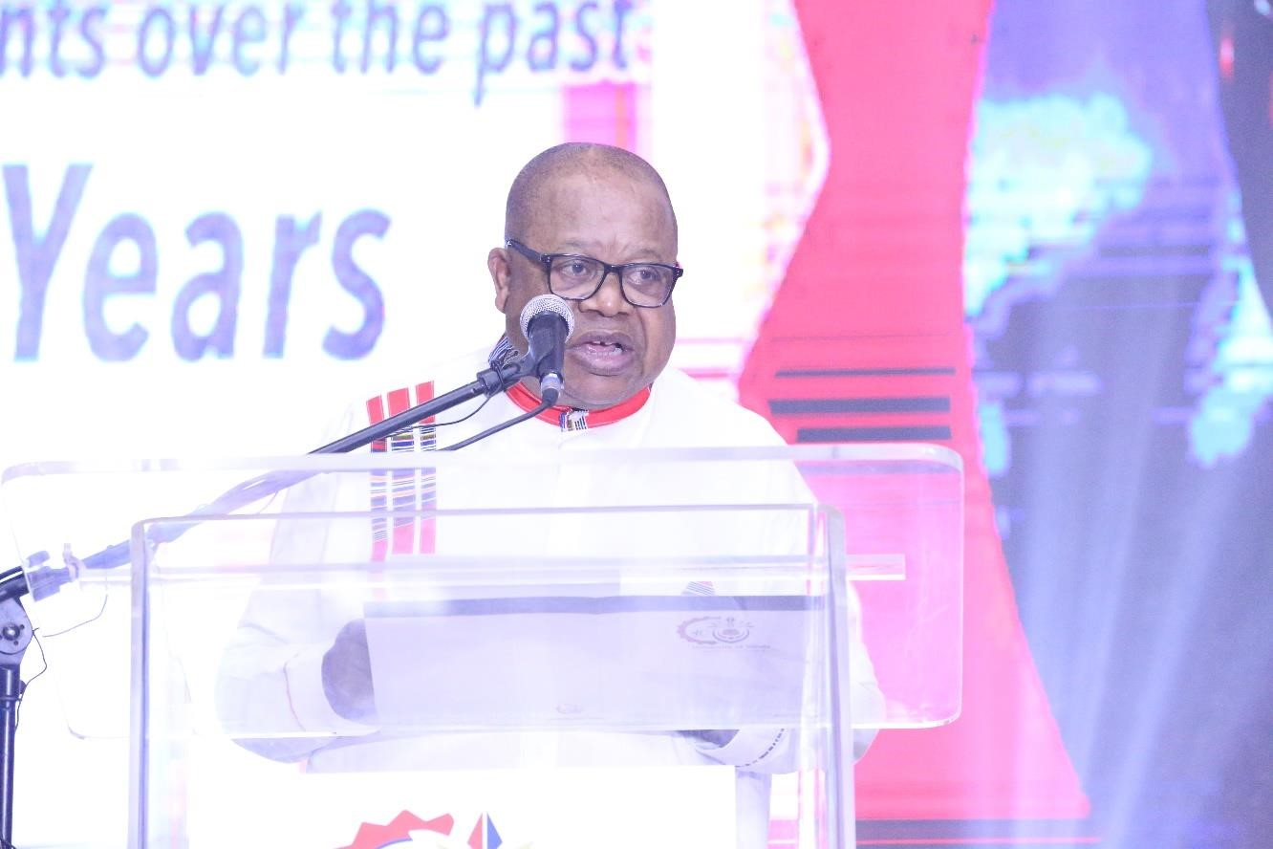

When opening and welcoming guests, the Chairperson of Council, Mr. Juneas Lekgetha indicated that over the past years, UNIVEN has produced great leaders whom today are making a remarkable impact locally and internationally. “We are proud to be a university that serves the children of not only this country but of the whole world.” He said UNIVEN will always ensure that it plays a leading role in our society.

The Chairperson of the University Council, Mr. Juneas Lekgetha said that the University of Venda Council pledges to continue playing the role of providing stewardship, guidance, and oversight to the University Management as per the mandate. Mr. Lekgetha expressed his gratitude to his fellow Council Members for their tireless effort in offering guidance to different Committees of the Council.

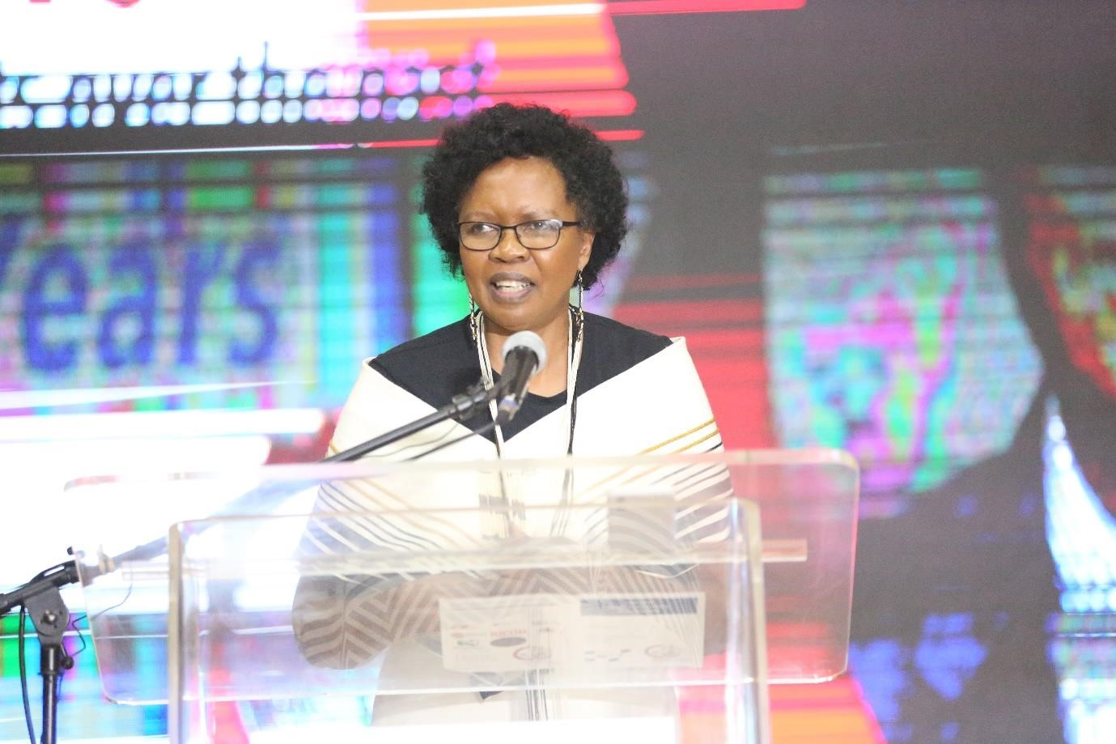

When acknowledging all messages from all speakers and those who wished UNIVEN well in its 40th Anniversary Celebration, UNIVEN Chancellor, Advocate Mojanku Gumbi said the leadership of this University is on a mission to build this country. “We always make sure that we produce responsible graduates who know how to lead themselves before they could lead others. UNIVEN produces graduates that aim to address challenges that are faced by this country and even the whole African continent.” Advocate Gumbi concluded her talk with the words that Africa needs analytical graduates who are ready to address African challenges.

Congratulatory messages were received from Mr. Gudani Tshamano (SRC President), Mr. Nditsheni Tshithavhane (Staff representative), Mr. Ntevheleni Thovhogi (Alumni), Mr. Norman Madzhinga (Afroshine Holdings-representing donors and sponsors), Prof J

Scharf MD MPH (the University of Virginia- international partnering university), Mr.

Sylvester Motadi (Convocation President), Prof Tshilidzi Marwala (UJ Vice-Chancellor – Representative of Institutions of Higher Learning), Dr. Phethiwe Matutu (USAF CEO), Cllr Dowelani Nenguda (Vhembe District Executive Mayor) and Thovhele MPK Tshivhase (Representing Traditional Leaders).

The event was sponsored by the following companies: Nedbank, MBG Hotel at 2Ten, Simeka Heights, Ricoh, Gochi Construction, KMS Architects, KC Maiwashe and Associates Quantity Surveyors, and Dembe Solutions.

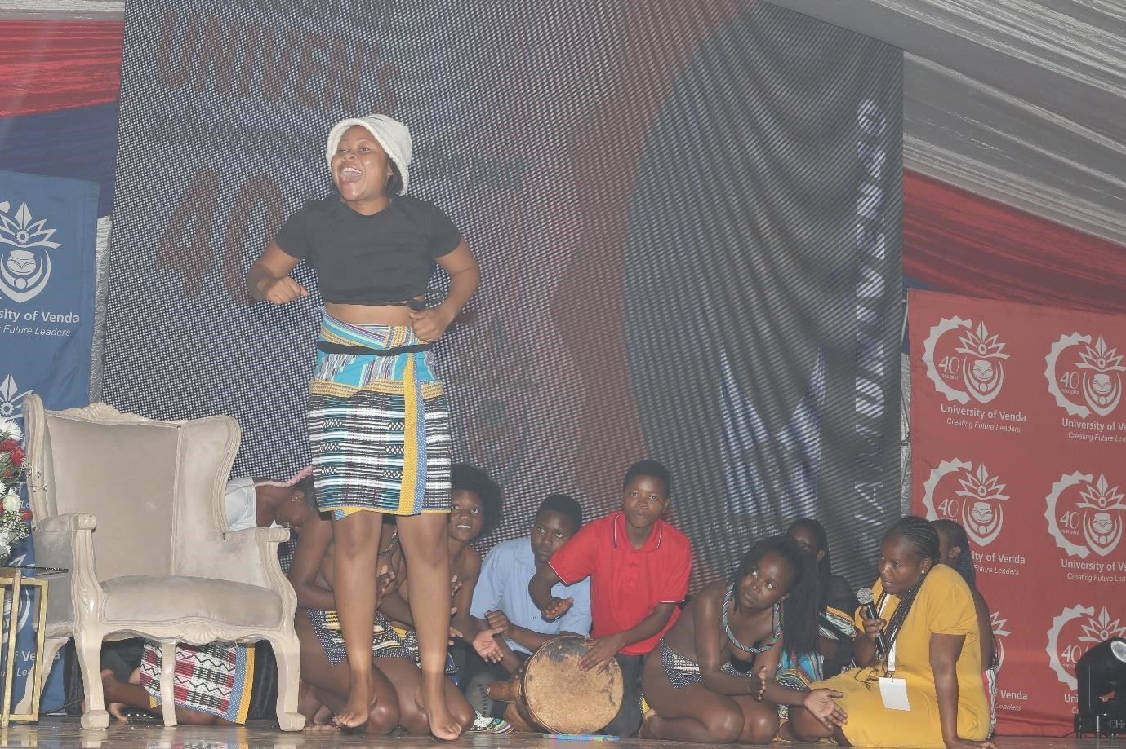

Tshivenda dance group performing Malende during the 40th Anniversary Celebration.



*Sepedi dance group performing during the 40th Anniversary Celebration*

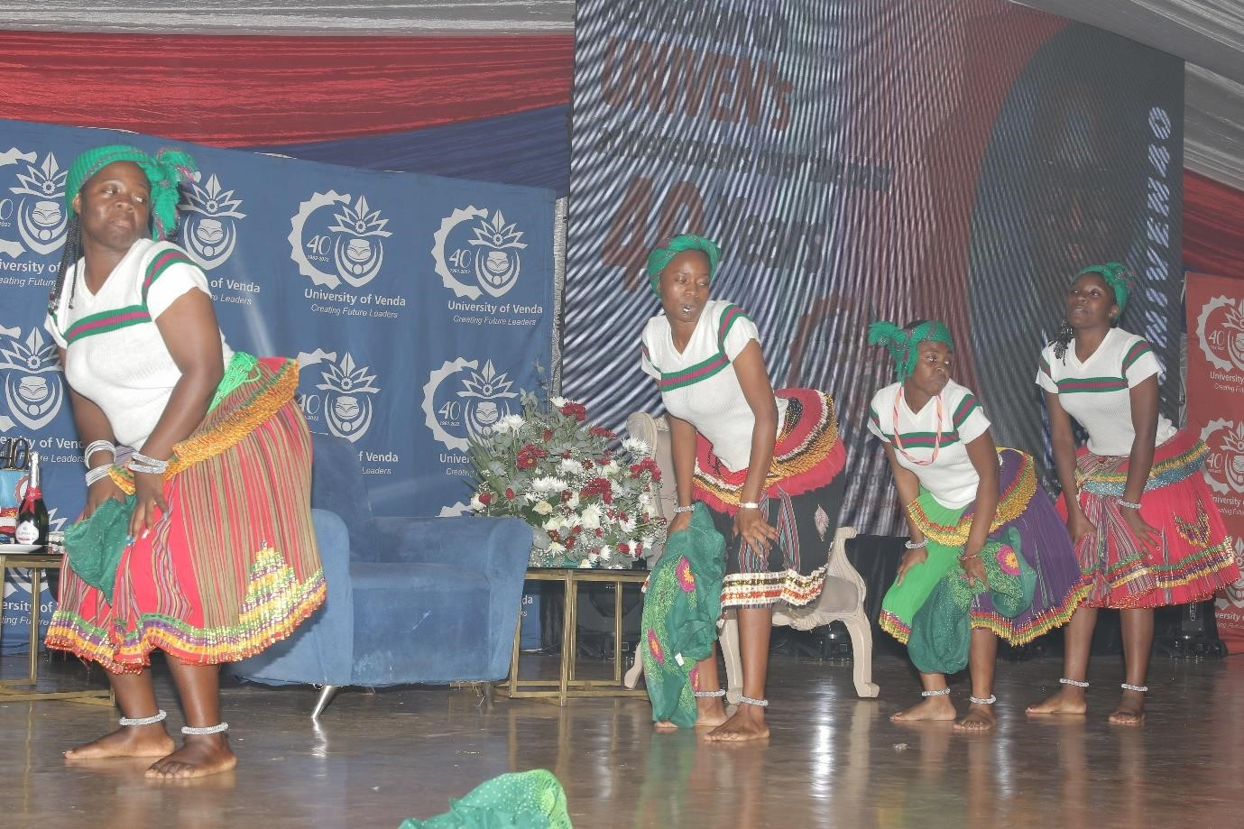

*Xitsonga dance group Performing during the 40th Anniversary Celebration*

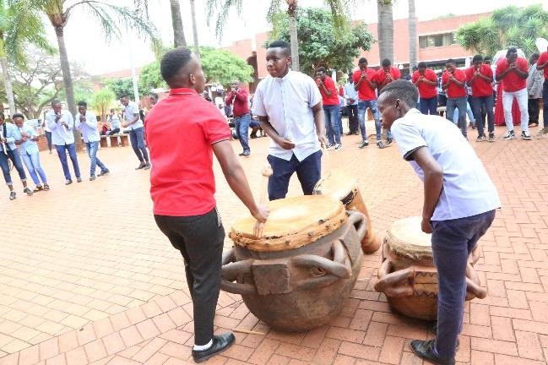

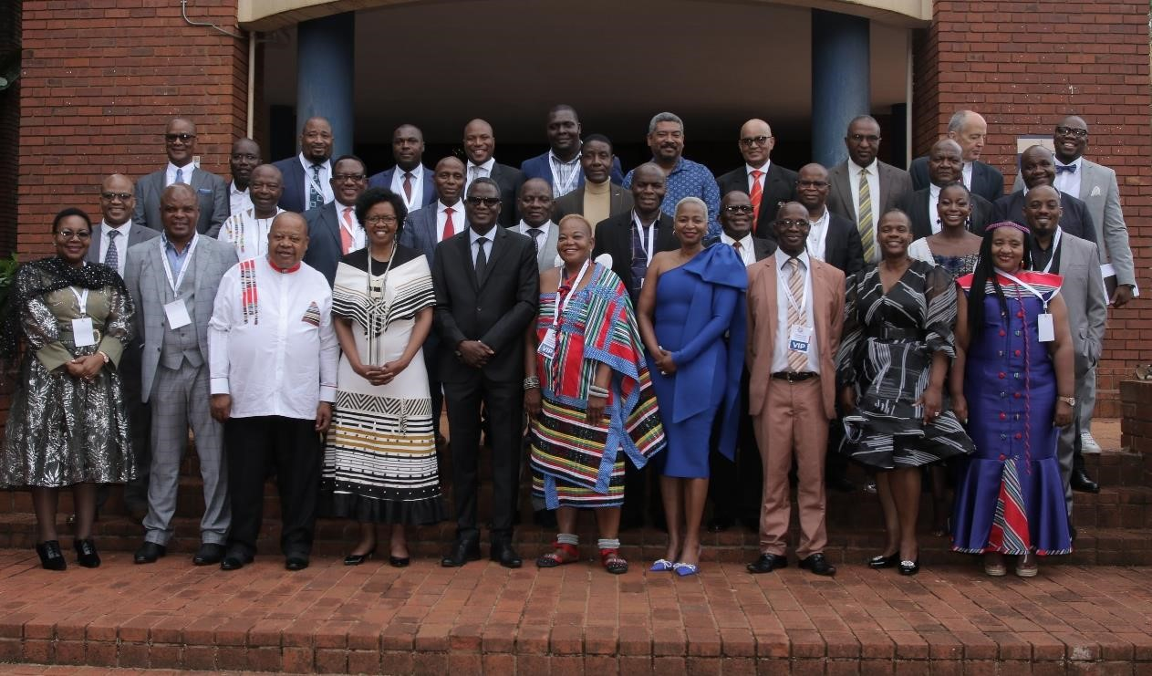

*A group photo of some of the dignitaries during the 40th Anniversary Celebration before the main event*

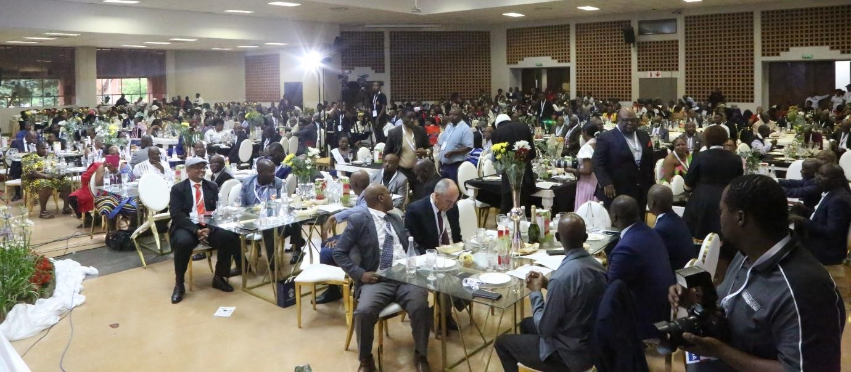

**Issued by:**

Department of Marketing, Branding and Communication

University of Venda

Tel: (015) 962 8525 / 8710

Date: 05 November 2022

