Department of Supply Chain Management and Expenditure: Addendum Date: 29 January 2024
Your ref: 35/2024

TO ALL SERVICE PROVIDERS

Dear Sir/Madam

RFQ NR: 35/2024: SUPPLY AND DELIVERY OF CLEANING MATERIAL : UNIVERSITY OF VENDA

ADDENDUM 1
This Addendum forms part of the RQF Documents and must be acknowledged by returning the attached form to this office.
The amendments listed/tabled below must be incorporated into the RFQ document as follows:

1. Submission address

RFQ Document
All Quotations Be Submitted:
Don.Mathebula@univen.ac.za or facilities tender box or office number 5

AMENDMENTS:
Replace the following in the original tender document | Replace with the following
Tender submission date: 29 January 2024@ 10H00 | 31 January 2024@ 12H00.

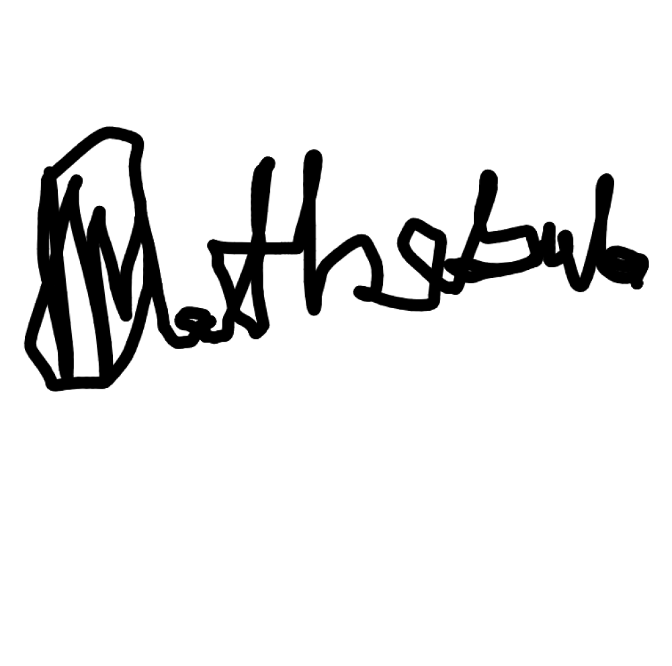
Yours faithfully

For University of Venda

