NOTICE OF INTENTION TO SUBMIT DISSERTATION FOR EXAMINATION

 | 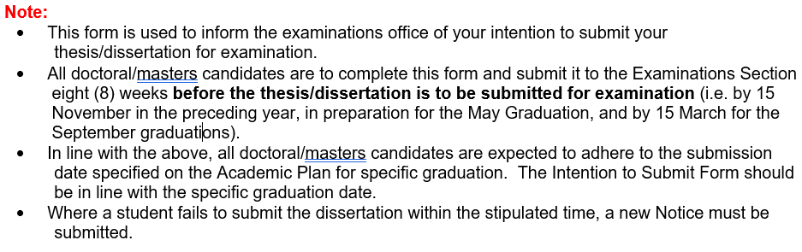

Candidate's full name

Student number

Email address

Contact number

Faculty

Department

Level

Supervisor’s full name

Supervisor’s email address

Co-supervisor’s full name

Co-supervisor’s email address

An approved dissertation title
I ACKNOWLEDGE THE FOLLOWING:

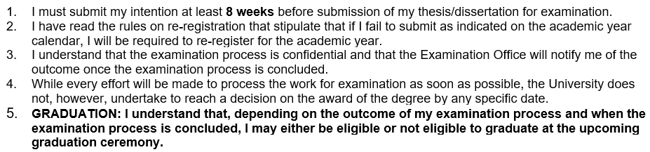
Masters / Doctoral Candidate
Signature |  |  |  | Date
Supervisor
I support the submission of this Dissertation for examination. (Please tick ) |  |  |  | Yes |  | No
Signature |  |  |  | Date

