





Hosted by the University of Venda
32ND ANNUAL CONFERENCE 2025 2025

Theme: Towards Excellence: Enhancing Funding Pathways and Student Outcomes through Human-Centric AI, Impactful Research, and Operational Intelligence



27 - 31 OCTOBER 2025


Kalahari Waterfront, Thohoyandou, Limpopo



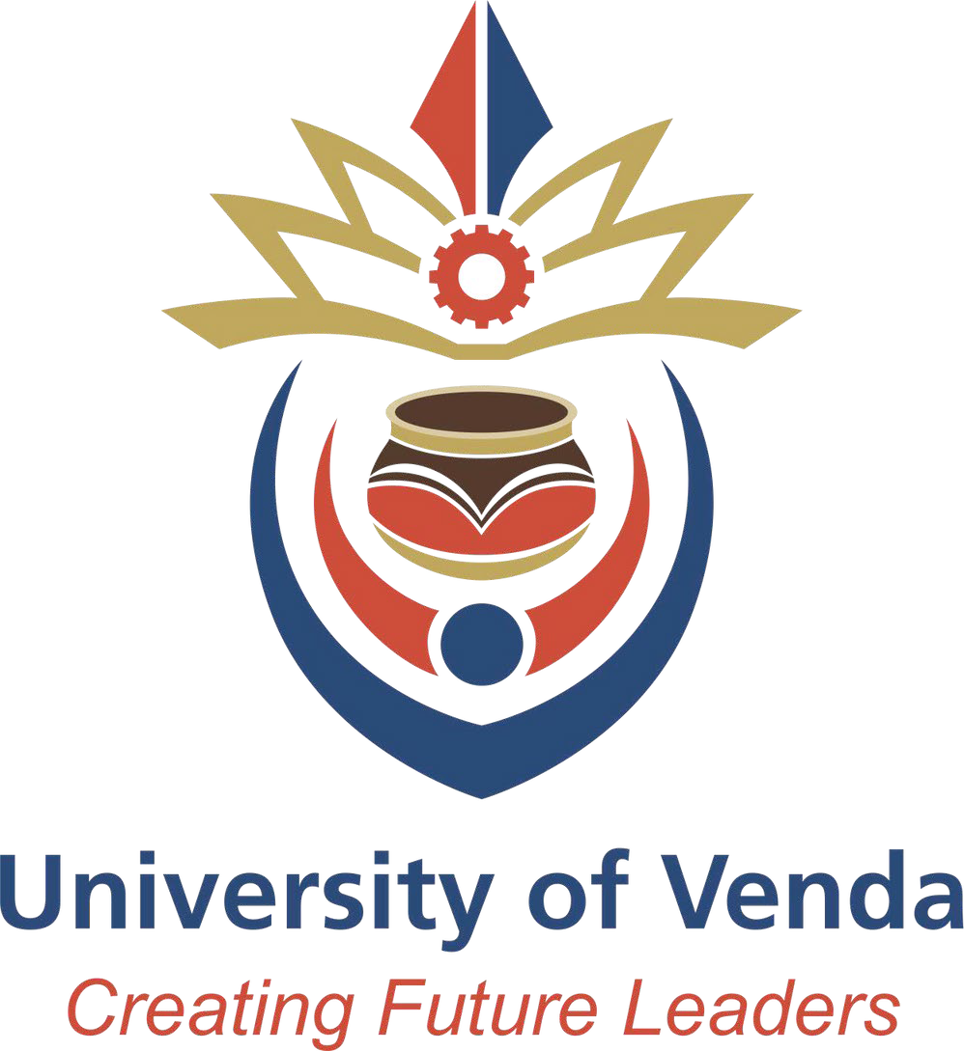

CREATING FUTURE LEADERS
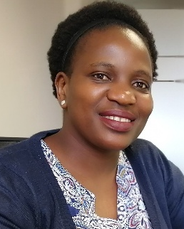
Elizabeth Booi
Message from the SAAIR President
Dear Conference Delegates,
It is an honour to welcome you to the 32nd Annual SAAIR Conference, hosted by the University of Venda, under the theme “Towards Excellence: Enhancing Funding Pathways and Student Outcomes through Human-Centric AI, Impactful Research, and Operational Intelligence.”
Since its establishment SAAIR has remained committed to advancing the understanding, planning, and operational effectiveness of higher education institutions in Southern Africa and beyond. The Association continues to serve as a professional home for practitioners dedicated to embedding data-informed decision-making, ethics, and equity within higher education systems.
The 2025 Conference builds on SAAIR Exco term office unifying framework DISCO – Data, Impact, Strategy, Capacity, and Optimisation. These five pillars guide our shared effort to strengthen institutional research practice, promote evidence-based governance, and enhance institutional resilience through innovation and collaboration. DISCO highlights the role of data in driving strategic impact, building capacity, and optimising operations through human-centred AI.
We are privileged to welcome a distinguished line-up of keynote speakers, invited speakers and workshop facilitators who bring diverse expertise and inspiration to our programme: Prof Riel Miller, Prof Thandi Lewin, Dr Erik Atchison, Dr Emily Mabote, and Prof Mosia Moeketsi, whose contributions strengthen our dialogue on futures literacy, funding sustainability, data governance, and responsible AI. We also look forward to the panel discussion on professionalising Institutional Research and related fields through a formal qualification, which will shape the future of our discipline and elevate professional standards.
My sincere appreciation goes to the SAAIR Executive Committee and Mrs Carin Strydom, the University of Venda leadership and Institutional Planning team, Conference sponsors: IDSC and Quantum Solution, and all those who have worked tirelessly to make this event possible. I also extend heartfelt thanks to all presenters and participants; your participation ensures that SAAIR remains a vibrant community of learning and professional growth. May this conference inspire meaningful connections, critical reflection, and collaborative action that advance excellence in higher education.
Warm regards,
Elizabeth Booi
President, Southern African Association for Institutional Research (2025–2026)

Message from Conference Chairperson, 32nd SAAIR Conference
Dr Sannah Mativandlela Mabote
It is my great honour and pleasure to welcome you all to the 32nd Southern African Association for Institutional Research (SAAIR) Conference, hosted by the University of Venda (UNIVEN). This Conference brings together distinguished higher education practitioners, scholars, researchers, industry leaders, academic staff and students who share a common passion for advancing knowledge and fostering innovation.
This year’s theme, ”Towards Excellence: Enhancing Funding Pathways and Student Outcomes through Human-Centric AI, Impactful Research, and Operational Intelligence”, invites us to reflect deeply on how we can collaboratively shape a future defined by excellence, sustainability, and human-centred progress within the higher education sector.
As Chairperson of the 32nd SAAIR Conference, I am grateful to the SAAIR Executive Committee, the UNIVEN Organising Committee, higher education practitioners, partners, and sponsors whose commitment and hard work have made this event possible. I also extend heartfelt appreciation to our keynote speakers, presenters and participants for their invaluable contributions and engagement.
I encourage you to take full advantage of this opportunity to share ideas and build networks that extend beyond this Conference. May our collective efforts lead to meaningful dialogue and lasting change in our various fields of knowledge and communities to enhance student access and success in higher education.
May this be a truly enriching and inspiring experience for us all.
Warm regards,
Sannah Patience Mativandlela
Conference Chairperson
Director Institutional Research and Planning, University of Venda
PRE-CONFERENCE WORKSHOPS: 27 October 2025
VENUE: MGB/ 2TEN
08:30-09:00 | Tea and Registration
09:00-09:20 | Welcome Address | SAAIR President
PRE-CONFERENCE WORKSHOPS
09:30-10:30 | WORKSHOP 1  Dr E Atchison  Vice President for Strategic Research  Arkansas State University System  Data literacy and visualization training for institutional leaders and IR professionals with Data Governance Implementation
10:30-11:00 | MORNING TEA BREAK
11:00-13:00 | PRE-CONFERENCE WORKSHOPS Continued
11:00-13:00 | WORKSHOP 1 (continued)

13:00-14:00 | LUNCH BREAK
14:00-15:30 | WORKSHOP 2  Prof R Miller  Former Head of Foresight and Future Literacy at UNESCO. Senior Fellow at: Ecole des Ponts Business School (France); U. New Brunswick (Canada); NIFU (Norway); U. Witwatersrand (South Africa); Future Africa at U. Pretoria (South Africa), and East China Normal U. (China).  The Future of Excellence In 2060: mini-futures literacy lab | WORKSHOP 3  Innocent Mamvura and Sibusiso Msomi  Agentic AI and Autonomous Agents in Higher Education: From Concept to Campus Implementation
15:30-15:45 | AFTERNOON TEA BREAK
15:45-17:15 | WORKSHOP 2 (continued) | WORKSHOP 3 (continued)
17:15 | END OF DAY  Social Event: “Tropical Sunset Soirée” @ MGB/2TEN

Day 1: 28 October 2025
Venue: Kalahari Waterfront, Thohoyandou, 0950, Limpopo Province,
08:00-09:00 | Tea and Registration
Plenary Session: Nkhelebeni Conference Centre
Chair: SAAIR President
09:00-09:20 | Welcome Remarks | Conference Chairperson:  Dr Patience Mativandlela
09:20-09:40 | Opening Address by SAAIR President | SAAIR President: Ms Elizabeth Booi
09:40-09:45 | Introduction of Keynote Speaker | SAAIR EXCO: Dr Hossein Karakani Masoumi
09:45-10:30 | Keynote Address:  The Trouble with Solutionism: futures literacy and the value of ‘not-knowing’ | Prof R Miller  Former Head of Foresight and Future Literacy at UNESCO. Senior Fellow at: Ecole des Ponts Business School (France); U. New Brunswick (Canada); NIFU (Norway); U. Witwatersrand (South Africa); Future Africa at U. Pretoria (South Africa), and East China Normal U. (China).
10:30-10:45 | Question and Answer Session
10:45-11:00 | Sponsor Presentation | Quantum Education Systems (Platinum partnership)
11:00-11:30 | Morning Tea Break

Plenary Session: Nkhelebeni Conference Centre
Chair: Sannah Patience Mativandlela
11:30-12:15 | Keynote Address  Combined Assurance in the Digital Era: Leveraging Technology and Data Governance for Effective Strategic Oversight. | Dr E Mabote  Acting Deputy Vice-Chancellor: Digital Transformation  Tshwane University of Technology
12:15-12:45 | Panel Discussion: Professionalising Institutional Research and Related Fields through a Formal Qualification | Dr Emily Mabote (Tshwane University of Technology)  Dr Remy Nnadozie (Rhodes University)  Dr Nandarani Maistry (University of Johannesburg)  Dr Mxolisi Masango (Cape Peninsula University of Technology)  Glen Barnes (IDSC)  Papama Somgede (University of Pretoria)
12:45-13:00 | Question and Answer Session
13:00-14:00 | Lunch Break
Plenary Session: Nkhelebeni Conference Centre
Chair: Hossein Masoumi Karakani
14:00-14:45 | Keynote Address:  Funding the Future: Advancing sustainability and stability for higher education systems: policy, planning, data and knowledge. | Prof T Lewin  Associate Professor  University of Johannesburg
14:45-15:00 | Question and Answer Session
15:00-15:30 | Tea Break
Parallel Sessions  15:30-16:00 | Parallel Sessions
Parallel Sessions  15:30-16:00 | Venue: Buruvhutsi  Chair: Lufuno Netshifhefhe | Venue: Zwiapenga  Chair: Tebogo Makhambeni | Venue: Mavhevhe  Chair: Zolani Fana
Parallel Sessions  15:30-16:00 | Session 1.1  Sub-theme: Bridging the Skills Gap: Empowering workforce development through human-centred AI and future-focused higher education. | Session 1.2  Sub-theme: Ensuring Excellence:  Enhancing quality assurance frameworks to support transformative, sustainable higher education systems. | Session 1.3  Sub-theme: From Insight to Impact: Strengthening strategic governance through data-driven decision-making and emerging technologies.
15:30-16:00 | 1: Presenter/s: Kabiru Ishola Genty and Sulaiman Olusegun Atiku  Title: Human Resource Analytics and Higher Education Institution Efficiency: An Empirical Evidence from Nigeria | 2: Presenter/s: Madoda Makola  Title: Ensuring Excellence through Integrated Institutional  Governance: Lessons from the Integrated Planning, Resource  Allocation and Quality Management (IPRAQuaM) Framework in  South African HEIs | 3: Presenter/s: Elizabeth Booi and Ronald Arendse  Title: Advancing Student Success Through Data-Informed Reform of Gateway Quantitative Modules
16:00 | Day End and UNIVEN Campus Tour

Day 2: 29 October 2025
Venue: Kalahari Waterfront, Thohoyandou, 0950, Limpopo Province
08:00-09:00 | Tea and Registration
Plenary Session: Nkhelebeni Conference Centre
Chair: Benjamin Ntshabele
09:00-09:20 | Welcome Remarks Conference Chairperson | Conference Chairperson: Dr Patience Mativhandlela
09:20-09:30 | Welcome and introduction of the Vice Chancellor and Principal of the University of Venda | Dr TV Dzaga  Director Marketing, Branding and Communication at the University of Venda
09:30-09:55 | Welcome Address | Prof NB Nthambeleni  Vice Chancellor and Principal of the University of Venda
09:55-10:40 | Keynote Address  Excellence in Action: Leveraging Operational Intelligence and Research to Enhance Student and Institutional Outcomes | Dr E Atchison  Vice President for Strategic Research  Arkansas State University System
10:40-10:50 | Question and Answer Session
10:50-11:00 | Sponsor Presentation | IDSC
11:00-11:30 | Morning Tea Break and Conference Photograph Session

Parallel Sessions  11:30-13:00 | Venue: Buruvhutsi  Chair: Innocent Mamvura | Venue: Zwiapenga  Chair: Lufuno Netshifhefhe | Venue: Mavhevhe  Chair: Tebogo Makhambeni
Parallel Sessions  11:30-13:00 | Session 2.1  Sub-theme: Bridging the Skills Gap: Empowering workforce development through human-centred AI and future-focused higher education. | Session 2.2  Sub-theme: Ensuring Excellence:  Enhancing quality assurance frameworks to support transformative, sustainable higher education systems. | Session 2.3  Sub-theme: From Insight to Impact: Strengthening strategic governance through data-driven decision-making and emerging technologies.
11:30-12:00 | 4: Presenter/s: Kirsten Lucas and Pieter Nagel  Title: Learning from the Dragon: Chinese Higher Education Insights for South Africa | 5: Presenter/s: Juan-Claude Lemmens  Title: Curriculum Analytics to Inform Curriculum Quality and Programme Reviews | 6: Presenter/s: Anri Wheeler  Title: Leveraging longitudinal Graduate data for strategic governance: A case study from a South African higher education institution
12:00-12:30 | 7: Presenter/s: Hossein Masoumi Karakani and Munienge Mbodila  Title: Strategic Workforce Planning in South African Higher Education: A Data-Driven Framework for Sustainable Institutional Development and NDP 2030 Alignment | 8: Presenter/s: Darlington Mutakwa, Nandarani Maistry, Takalani Muloiwa-Klenam and Thato Bhembe  Title: A deep dive into male participation in higher education | 9: Presenter/s: Mari Ford and Darlington Chigori  Title: Tracing Graduate Pathways: Insights from a Graduate Destination Study at the University of Fort Hare
12:30-13:00 | 10: Presenter/s: Munienge Munienge, Louis Mapatagane, Anele Bangani, Nocwaka Pangwa and Xolisa Mabunu  Title: Students’ Perceptions on the Support Received from Academic Advisors: A Reflection on the Students of Interest Follow up Survey | 11: Presenter/s: Olushola Olatunji  Title: Quality Assurance in South African Higher Education: A Transformative Framework for the 21st Century | 12: Presenter/s: Alugumi Ndou and Mpeiwa Thanyani  Title: Role of library in enhancing student success in historical disadvantaged university
13:00-14:00 | Lunch Break

 | Parallel Sessions
Parallel Sessions  14:00-15:30 | Venue: Buruvhutsi  Chair: Benjamin Ntshabele | Venue: Zwiapenga  Chair: Munienge Mbodila | Venue: Mavhevhe  Chair: Valentine Maroga
Parallel Sessions  14:00-15:30 | Session 2.4  Sub-theme: Funding the Future: Advancing sustainable financial  planning and resource optimisation in a rapidly evolving  academic landscape. | Session 2.5  Sub-theme: Ensuring Excellence:  Enhancing quality assurance frameworks to support transformative, sustainable higher education systems. | Session 2.6  Sub-theme: From Insight to Impact: Strengthening strategic governance through data-driven decision-making and emerging technologies.
14:00-14:30 | 13: Presenter/s: Cecilia Frans and Morongwa Selolo  Title: Critical Analysis of University Funding for Postgraduate Programs | 14: Presenter/s: Anri Wheeler and Laurika Wiese  Title: Collaborative quality enhancement: A narrative analysis of the impact of a Quality Exchange Forum on quality in South African Higher Education | 15: Presenter/s: Liberty Takudzwa Nyete  Title: Predictive Analytics in Student Support: Building a Sustainable Ecosystem at a Higher Institution.
14:30-15:00 | 16: Presenter/s: Mbongi Ndlovu and Glen Barnes  Title: Towards resource optimisation - Differentiating the financial contributions of academic units | 17: Presenter/s: Sulaiman Atiku and Himeesora Kaimu  Title: Exploring the Plausible Pathways toward Inclusive and Equitable Education 5.0: An Appreciative Inquiry for Quality Higher Education in Namibia | 18: Presenter/s: Hossein Masoumi Karakani, Mxolisi Masango and Takalani Muloiwa-Klenam  Title: From Entry to Exit: A Data-Driven Framework for a Student-Centered Recommender System within the South African Higher Education Sector
15:00-15:30 | Afternoon Tea Break

 | Parallel Sessions
Parallel Sessions  15:30-16:30 | Venue: Buruvhutsi  Chair: Benjamin Ntshabele | Venue: Zwiapenga  Chair: Zolani Fana | Venue: Mavhevhe  Chair: Hossein Masoumi Karakani
Parallel Sessions  15:30-16:30 | Session 2.7  Sub-theme: Funding the Future: Advancing sustainable financial  planning and resource optimisation in a rapidly evolving  academic landscape. | Session 2.8  Sub-theme: Global and Continental Commitments:  Advancing higher education’s role in achieving the UN 2030 SDGs and Africa’s Agenda 2063 aspirations. | Session 2.9  Sub-theme: From Insight to Impact: Strengthening strategic governance through data-driven decision-making and emerging technologies.
15:30-16:00 | 19: Presenter/s: Thembelihle Luthuli  Title: Policy Intentions to Practice: Analysing Planned Funding Allocations in South African Higher Education (2019–2023) | 20: Presenter/s: Valentine Maroga and Njabulo Ngobese  Title: Aligning Research Funding Strategies with National Development Goals: A UoT Perspective | 21: Presenter/s: Herman Janse van Vuuren  Title: Module Review Process to Enhance Success in High Impact Modules
16:00-16:30 | 22: Presenter/s: Darlington Mutakwa  Title: Student Debt – Can We Resolve It or Learn to Live With It? | 23: Presenter/s: Siphelo Mapolisa, Dorah Queen Sekhosana and Tshegofatso Kgomo  Title: Exploring Student Safety Experiences in ODeL: Challenges and Best Practices Report | 24: Presenter/s: Anele Bangani and Munienge Mbodila  Title: The 'Matriculation Gap' and Students’ University Success: A case student of a South African Higher Education Institution
16:30 | End of Day 2
18:00-23:00 | Gala Dinner  Dress Code: Formal/Black Tie @Porche-Villa Hotel and Conference Centre

Day 3: 30 October 2025
Venue: Kalahari Waterfront, Thohoyandou, 0950, Limpopo Province
08:00-09:00 | Registration and Tea
Plenary Session: Nkhelebeni Conference Centre
Chair: Hossein Masoumi Karakani
09:00-09:10 | Welcome Remarks and Reflections of Day 1 and 2 |  | SAAIR EXCO: Dr Mbodila Munienge
09:10-09:40 | Keynote:  From Crisis to Capability: Building AI That Works Where It Matters Most for Learning |  | Prof M Mosia  Vice-Dean: Teaching and Learning  University of the Free State
09:40-10:00 | Demonstration:  Platform Walkthrough: Making Expert Mathematics Teaching Accessible at Scale through our AI-powered platform. |  | Prof M Mosia  Vice-Dean: Teaching and Learning  University of the Free State
10:00-10:30 | Question and Answer Session
10:30-11:00 | Morning Tea Break
Parallel Sessions  11:00-11:30 | Parallel Sessions
Parallel Sessions  11:00-11:30 | Venue: Buruvhutsi  Chair: Vhutshilo Nekhubvi | Venue: Zwiapenga  Chair: Innocent Mamvura |  | Venue: Mavhevhe  Chair: Elizabeth Booi
Parallel Sessions  11:00-11:30 | Session 3.1  Sub-theme: Global and Continental Commitments: Advancing higher  education’s role in achieving the UN 2030 SDGs and Africa’s  Agenda 2063 aspirations | Session 3.2  Sub-theme: Bridging the Skills Gap: Empowering workforce development through human-centred AI and future-focused higher education. |  | Session 3.3  Sub-theme: Funding the Future: Advancing sustainable financial planning and resource optimisation in a rapidly evolving academic landscape.
11:00-11:30 | 25: Presenter/s: Alugumi Ndou and Jerry Mahlangu  Title: Information literacy instruction as a student-success ecosystem at a South-African university | 26: Presenter/s: Hloniphile Cleopatra Zwane, Thembisile Alice Ndimande and Victor Halalisani Mlambo  Title: Artificial Intelligence as a catalyst to Enhance Teaching, Learning, and Decision-Making in Higher Education: A South African Perspective |  | 27: Presenter/s: Remy Nnadozie  Title: The Impact of Higher Education Sector Changes on Mathematical Parameters of South Africa's Funding Formula for Public Universities
11:30-12:00 | 28: Presenter/s: Loquitur Maka  Title: Ready or Not? Unpacking Digital Divides in First-Year Students’ University Preparedness | 29: Presenter/s: Azwy Christopher Tshivhase and Denise Rosemary Nicholson  Title: Transforming Higher Education Through AI Innovation: The Role of the University of South Africa (Comprehensive Open Distance E-Learning Institution). |  | 30: Presenter/s: Valentine Maroga and Modjadji Mtsweni  Title: The Role of Research Outputs in Attracting External Funding and Enhancing Reputation
12:00-13:30 | Plenary Session: Main Venue  SAAIR AGM |  | SAAIR EXCO
13:30-14:30 | Lunch Break
Parallel Sessions  14:30-15:00 | Parallel Sessions
Parallel Sessions  14:30-15:00 | Venue: Buruvhutsi  Chair: Elizabeth Booi | Venue: Zwiapenga  Chair: Benjamin Ntshabele |  | Venue: Mavhevhe  Chair: Valentine Maroga
Parallel Sessions  14:30-15:00 | Session 3.4  Sub-theme: Ensuring Excellence:  Enhancing quality assurance frameworks to support transformative, sustainable higher education systems. | Session 3.5  Sub-theme: Ensuring Excellence:  Enhancing quality assurance frameworks to support transformative, sustainable higher education systems. |  | Session 3.6  Sub-theme: From Insight to Impact: Strengthening strategic governance through data-driven decision-making and emerging technologies.
14:30-15:00 | 31: Presenter/s: Vakele Nobongoza and Somarie Hotlzhausen  Title: Towards Excellence in Navigating Institutional Pressures and Contingencies: a Neo-Institutional and Contingency Analysis of Internal Quality Assurance in South African Comprehensive Universities | 32: Presenter/s: Hossein Masoumi Karakani and Ashton Maherry  Title: From Compliance to Collaboration: Leveraging Institutional Audit Outcomes for Strategic Improvement in South African Higher Education |  | 36: Presenter/s: Innocent Mamvura and Lerato Makuapane  Title: Falling Behind: A Mixed-Methods Analysis of Male Student Success in South African Universities
15:00-18:00 | Community Outreach: Tshakhuma Fruit & Vegetable Market

Day 4: 31 October 2025
Venue: Kalahari Waterfront, Thohoyandou, 0950, Limpopo Province
08:00-09:00 | Registration and Tea
Parallel Sessions  09:00-10:00 | Parallel Sessions
Parallel Sessions  09:00-10:00 | Venue: Buruvhutsi  Chair: Ashton Maherry | Venue: Zwiapenga  Chair: Benjamin Ntshabele
Parallel Sessions  09:00-10:00 | Session 4.1  Sub-theme: Bridging the Skills Gap: Empowering workforce development through human-centred AI and future-focused higher education. | Session 4.2  Sub-theme: Ensuring Excellence:  Enhancing quality assurance frameworks to support transformative, sustainable higher education systems.
09:00-09:30 | 34: Presenter/s: Elizabeth Booi  Title: Building a Data Culture: Advancing Digital and Data Literacy | 35: Presenter/s: Thato Mokoma  Title: Advancing Equity Through Analytics: The Role of Eigenvalues in Strengthening Standardisation in Education
09:30-10:00 | 36: Presenter/s: Murendeni Mukwevho and Kevin Silomo  Title: Empowering workforce development through human-centric Ai | Session 4.3  Sub-theme: From Insight to Impact: Strengthening strategic governance through data-driven decision-making and emerging technologies.
09:30-10:00 |  | 37: Presenter/s: Lerato Makuapane and Fezile Wagner  Title: Designed with students, for students: validating the mental health assessment tools used in the Fit Minds Survey through student voice.
10:00-10:30 | Morning Tea Break

Parallel Sessions  10:30-11:30 | Parallel Sessions – Panel Discussions
Parallel Sessions  10:30-11:30 | Venue: Buruvhutsi  Chair: Sannah Patience Mativandlela | Venue: Zwiapeng  Chair: Benjamin Ntshabele
Parallel Sessions  10:30-11:30 | Session 4.5  Sub-theme: From Insight to Impact: Strengthening strategic governance through data-driven decision-making and emerging technologies. | Session 4.6  Sub-theme: Sub-theme: From Insight to Impact: Strengthening strategic governance through data-driven decision-making and emerging technologies.
10:30-11:30 | Panel Discussion Title: AI for Institutional Operational Excellence and Strategic Foresight: Opportunities, Risks, and Real-World Practice  Panellist /s: Innocent Mamvura (University of the Witwatersrand)  Dr Eric Atchison (Arkansas State University System)  Dr Mbodila Munienge (Walter Sisulu University)  Prof Sulaiman Olusegun Atiku (Namibia University of Science and Technology)  Prabashnee Kisten (Durban University of Technology) | Panel Discuss Title: I Am: Embedding the Student Voice in Higher Education through Siyaphumelela  Panellist /s: Panellists: Ashton Maherry (Saide)  Simphiwe Kunene (Varsity College)  Bradley Gawie (Central University of Technology, Free State)
Plenary Session: Nkhelebeni Conference Centre
Chair: Hossein Masoumi Karakani
11:35-12:35 | Panel Discussion: SAAIR Scholars | Panellists: Luna August (University of Cape Town)  Lerato Makuapane (University of the Witwatersrand)  Lebohang Mojapelo (University of Pretoria)  Zanele Maloyi (University of South Africa)
12:35-12:45 | Conference Closure | SAAIR President: Ms Elizabeth Booi
12:45 | Lunch and Departure

Dr Eric Atchison
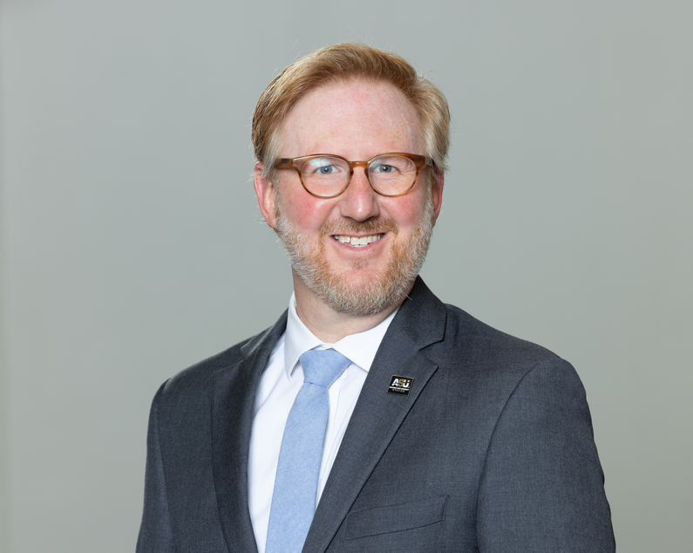
Eric Atchison serves as Vice President for Strategic Research with the Arkansas State University System. In this role, he is responsible for managing the system-wide data function and develops cost accounting analyses to support institutional management efforts. During his tenure, he has developed and implemented a system-wide data system and expanded data collection efforts across the seven institutions of the ASU System, supported the migration to one ERP system, and produced a wide variety of user-friendly interactive dashboard reports and statistical publications. He has over 17 years of experience in higher education at the institution, state, and system levels and also served in a variety of leadership roles within state, regional, and national IR associations; including as chair of the 2024-2025 AIR Nominations and Elections Committee, secretary of the board for the Southern Association for Institutional Research, treasurer for the Arkansas Institutional Research Organization, and president for the Mississippi Association for Institutional Research.

He has contributed to numerous efforts within the Association for Institutional Research, including serving as an IPEDS Educator, a subject matter expert for the National Survey of IR Offices, and mentor/lecturer for the Holistic Approach to IR course, the Foundations of IR workshop series, and the Data Literacy Institute programs. In addition, he co-curates and distributes the weekly e-newsletter, The Node for IR/IE, which is distributed weekly to more than 2,300 subscribers.

Prof Riel Miller
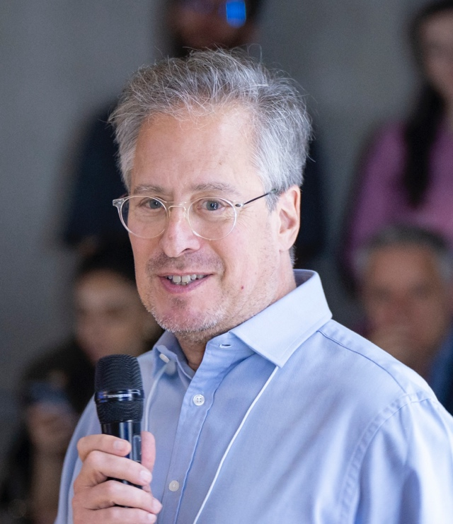
Riel Miller, starting in March of 2022 after a decade as Head of Foresight and Futures Literacy at UNESCO in Paris, joined several communities (see list below) seeking to transform why and how people use-the-future. He has worked as a senior manager in the Ontario public service (Ministries of Finance; Universities; Industry) and at the OECD in Paris (Economics; Science & Technology; Education; Territorial Development; Development Centre; International Futures Programme). In 2005 he founded a consultancy – xperidox to advise clients on how to use the future more effectively. In 2012 he was appointed Head of Foresight at UNESCO.

From the outset of his career, in 1982 at the OECD, Riel has accumulated hundreds of hands-on experiences, all around the world, designing and implementing efforts to think about the future. He is an experienced and innovative educator, a pioneer of the field of futures literacy and the ‘discipline of anticipation’. He is widely published in academic journals and other media on a range of topics, from the future of education and the Internet to the transformation of leadership and productivity. He is an accomplished keynote speaker and facilitator. His unflagging ambition is to find ways to put the richness of complex emergence at the service of humanity's capacity to be free.

Prof Moeketsi Mosia Atchison

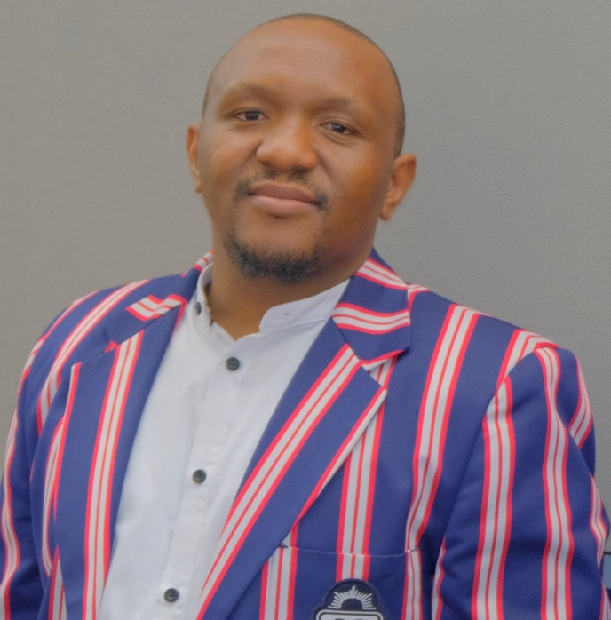
Moeketsi Mosia, is a Vice-Dean: Teaching and Learning and an Associate Professor in the Faculty of Education at the University of the Free State, where he holds the ETDP-SETA Research Chair in Mathematics Education. Previously the Director of Sol Plaatje University’s Centre for Teaching, Learning and Programme Development and Acting Director of Research, he led institution-wide quality assurance, digital transformation, and research systems automation.

His work sits at the intersection of mathematics education, data science, cloud computing, and learning analytics, advancing evidence-based teaching and student success. He has delivered production-scale analytics and cloud solutions. Prof Mosia has authored over 38 peer-reviewed publications (2016–2025) spanning mathematics education, educational technology, AI/Machine Learning in education, and data analytics.

Dr Emily Mabote

Emily Mabote currently serves as Acting Deputy Vice-Chancellor: Digital Transformation at the Tshwane University of Technology. She brings over 20 years of experience in higher education, including more than a decade in senior leadership, with expertise spanning quality assurance, institutional audits, national reviews, programme accreditation, and quality management system.
She has participated in institutional and external quality assurance projects that have advanced quality improvement in higher education. In her current executive role, Dr Mabote provides strategic leadership across a diverse portfolio that includes Strategic Management Support (covering Strategy, Statutory Reporting, and Business Intelligence), Risk Management, Quality Promotion, ICT Services, Internal Audit, Teaching and Learning with Technology, and Combined Assurance.
She also serves as the University’s Deputy Information Officer. She plays an active role in institutional governance through her serving on the Executive Management Committee and academic, operational, and governance structures, where she advances evidence-based decision-making, institutional effectiveness, and digital transformation.

Prof Thandi Lewin

Thandi Lewin is an Associate Professor in the Ali Mazrui Centre for Higher Education Studies and the Department of Education Management and Leadership in the Faculty of Education at the University of Johannesburg.
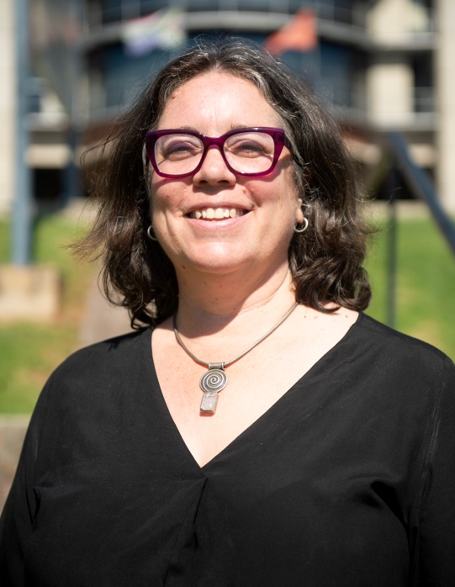
Prior to joining UJ, she worked in the South African Department of Higher Education and Training (DHET) as the Chief Director for Institutional Governance and Management Support in the University Education branch. Her responsibilities included student funding policy, university governance oversight, and student development and support matters. She worked in a number of roles within the national government departments for education. She has extensive experience in higher education policy, education and social justice, education monitoring and evaluation, and education management and governance.
Her research interests are higher education policy, gender in higher education, academic careers, leadership, management and governance in higher education, funding of higher education and the history of higher education policy.
https://www.uj.ac.za/faculties/education/centres/ali-mazrui-centre-for-higher-education-studies/

Tshakhuma Fruit and Vegetable Market was established more than 40 years ago, and today it remains the only 24-hour fruit market in South Africa. The market is situated in Venda, Tshakuma, Limpopo Province, 17km west of Thohoyandou on the Road to Makhado (Louis Trichardt), along the R524 road. The market offers quality fruits as it is near by Levubu farms which constantly supply fresh fruit.
Community Outreach:
Tshakhuma Fruit & Vegetable Market
A visit to Tshakhuma Fruit and Vegetable Market is a lively and memorable experience. The market is well known for its wide variety of fresh fruits and vegetables sold by local vendors. Stalls are filled with colourful produce such as bananas, avocados, mangoes, papayas, oranges, sweet potatoes, and leafy greens, creating a vibrant atmosphere.
The market is not only a place to buy affordable and fresh food, but also a hub of cultural exchange where visitors interact with friendly traders and learn about local farming practices. The energy, aroma of ripe fruit, and welcoming smiles make Tshakhuma Market a unique stop that showcases the richness of Limpopo’s agricultural life.
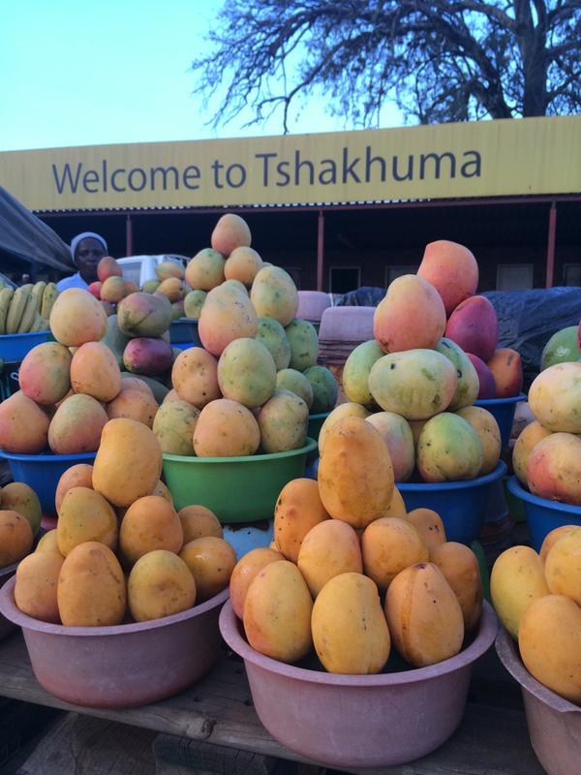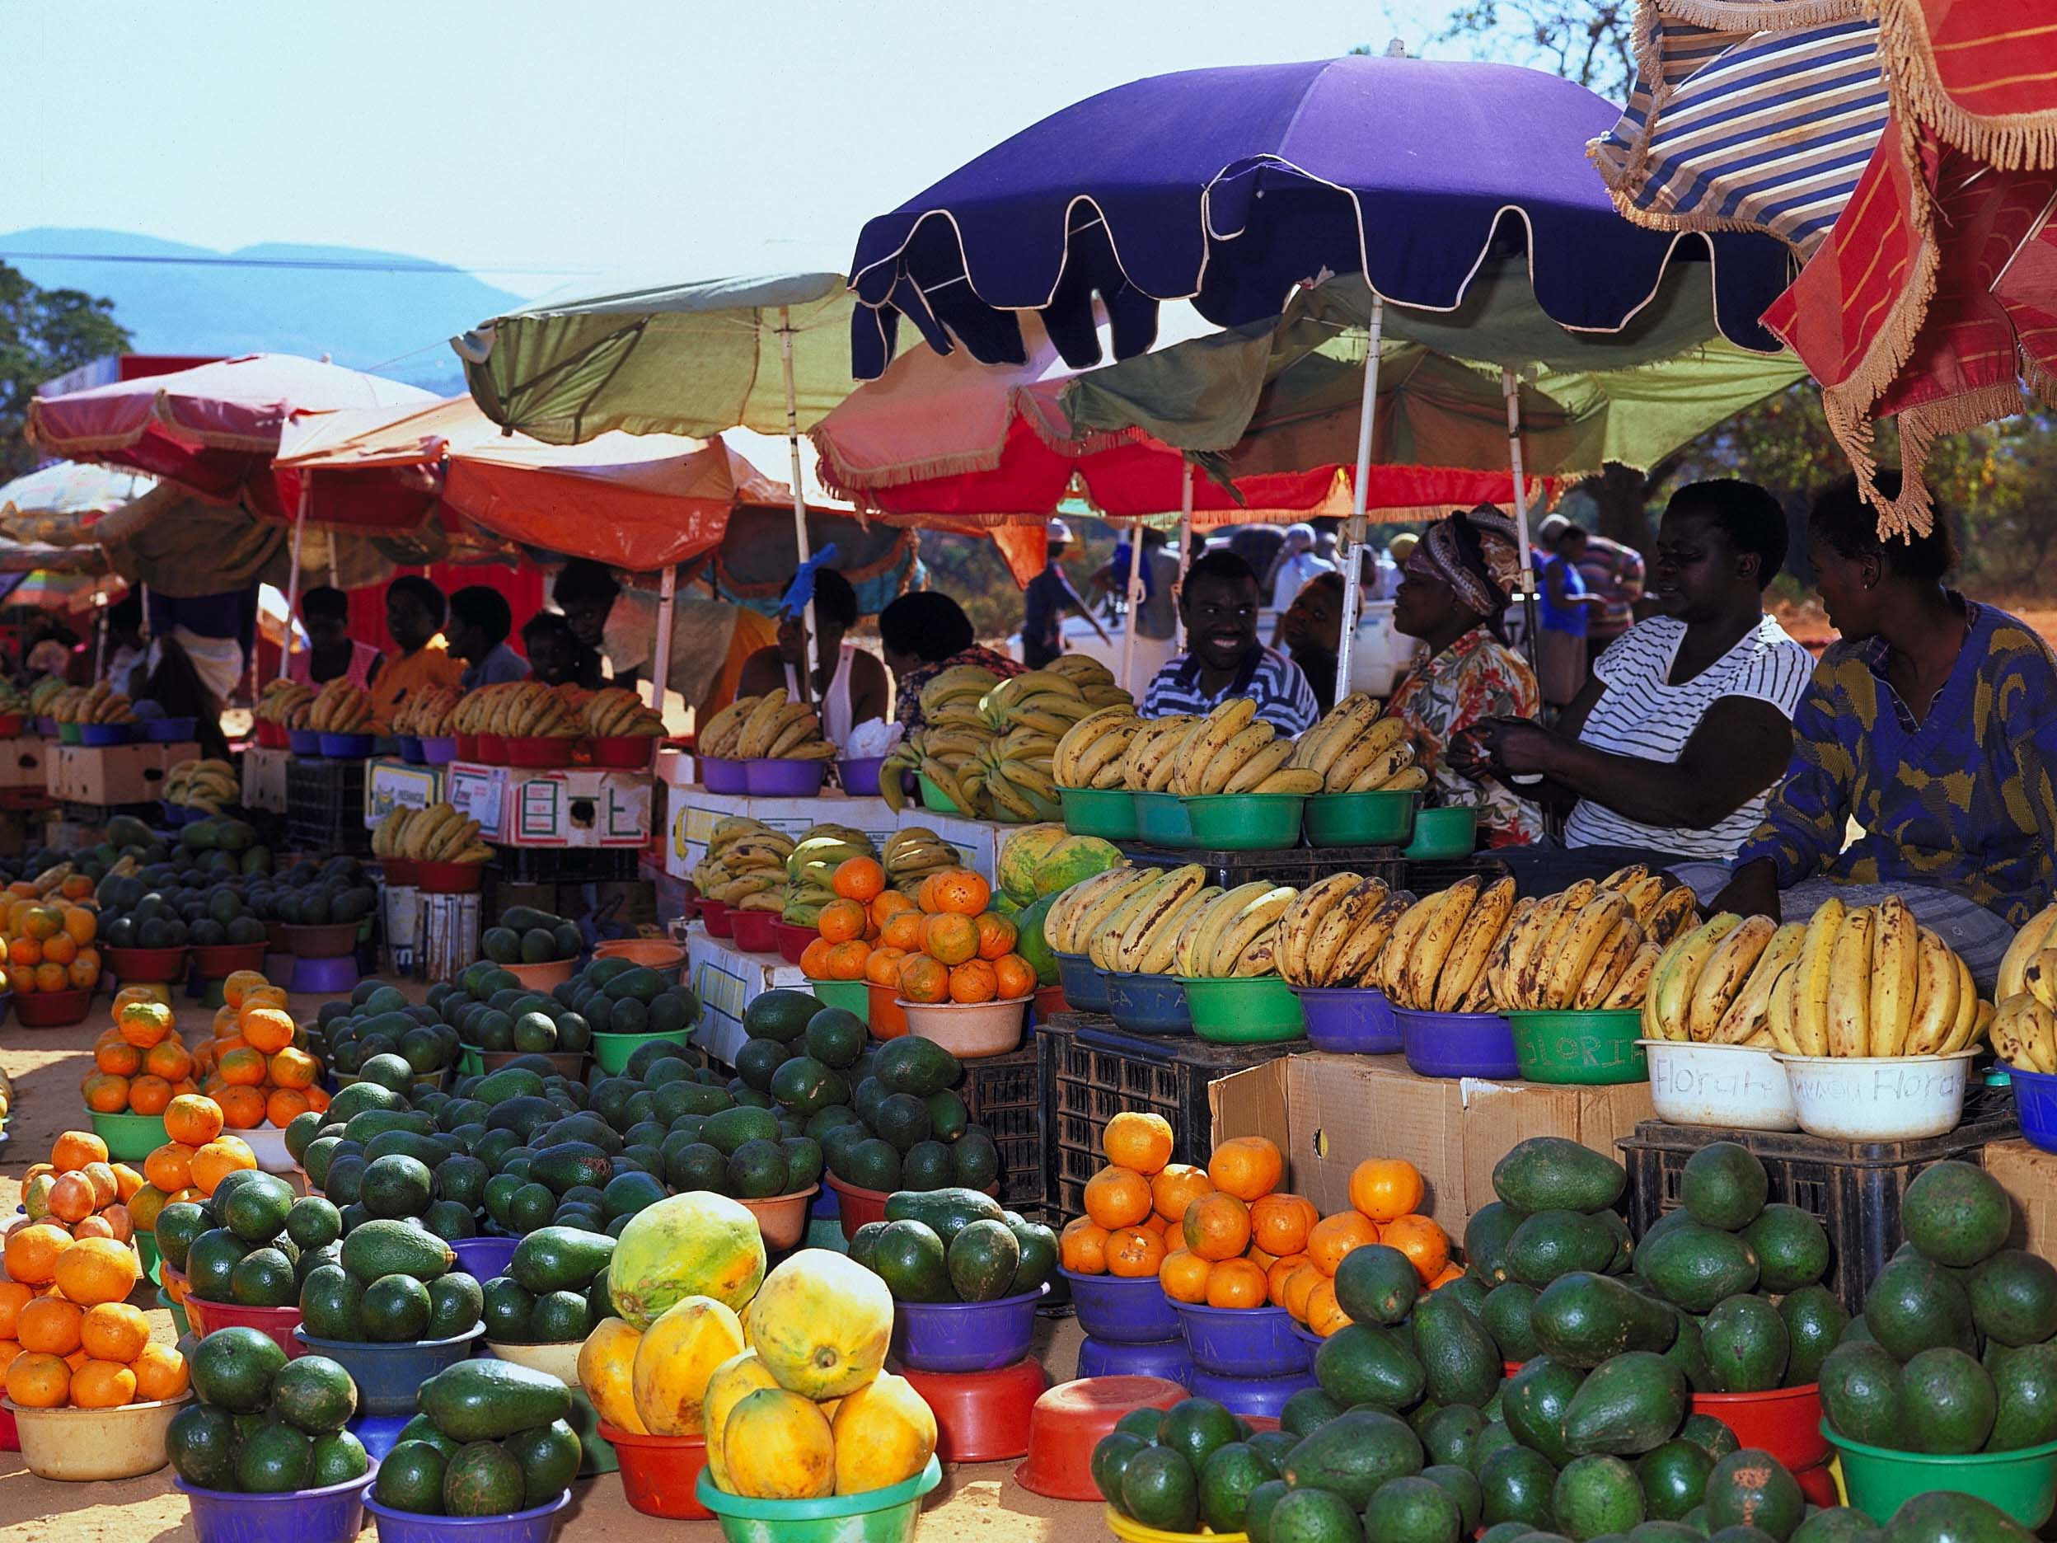
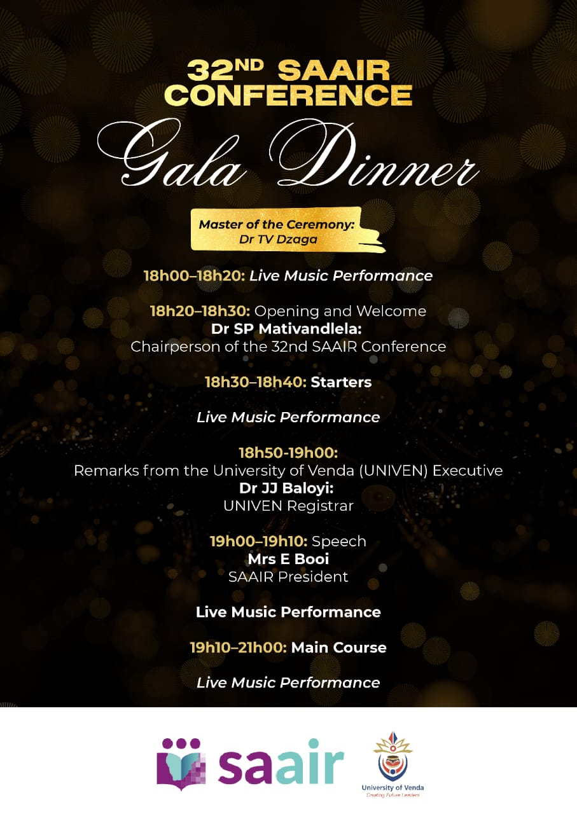
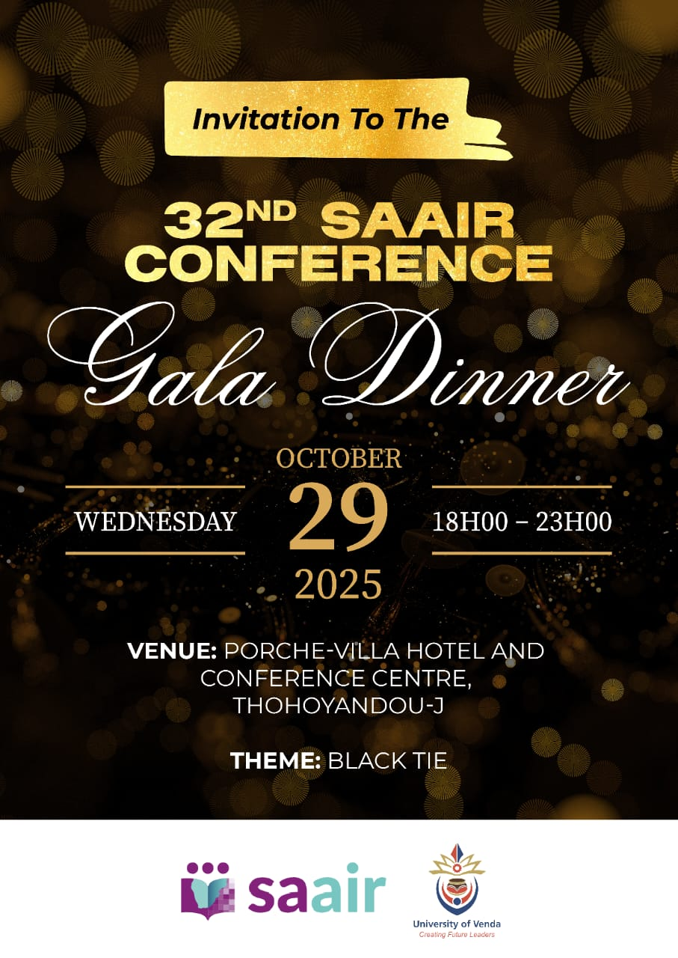

UNIVEN Task Team for the 2025 SAAIR Conference

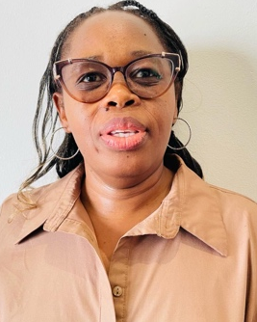
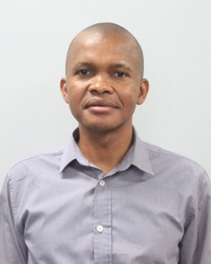
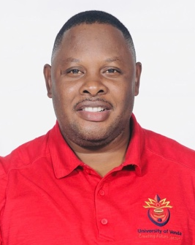


Tebogo
Makhambeni
Koketjo Lekoane
Tiyani Mboweni
Beauty
Mutheiwana
Sannah
Mativandlela

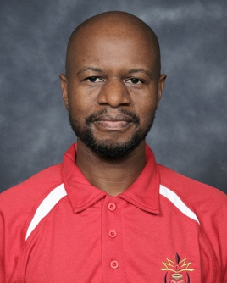
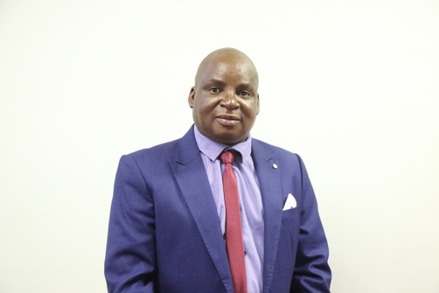
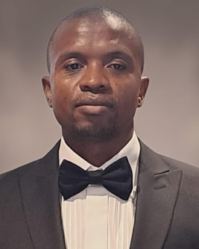
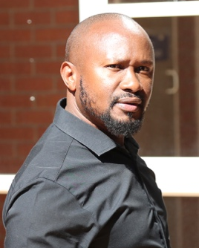

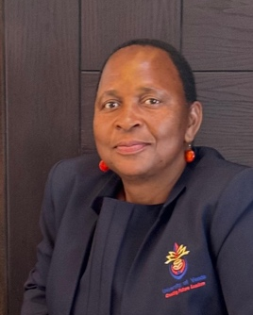
Alugumi
Ndou
Lugisani
Managa
Thabani
Njaba
Lufuno
Netshifhefhe
Livhuwani
Mudau
Peter
Mashishi
Royal
Nelwamondo

Sponsors




