





Hosted by the University of Venda
32ND ANNUAL CONFERENCE 2025 2025

Theme: Towards Excellence: Enhancing Funding Pathways and Student Outcomes through Human-Centric AI, Impactful Research, and Operational Intelligence



27 - 31 OCTOBER 2025


Kalahari Waterfront, Thohoyandou, Limpopo



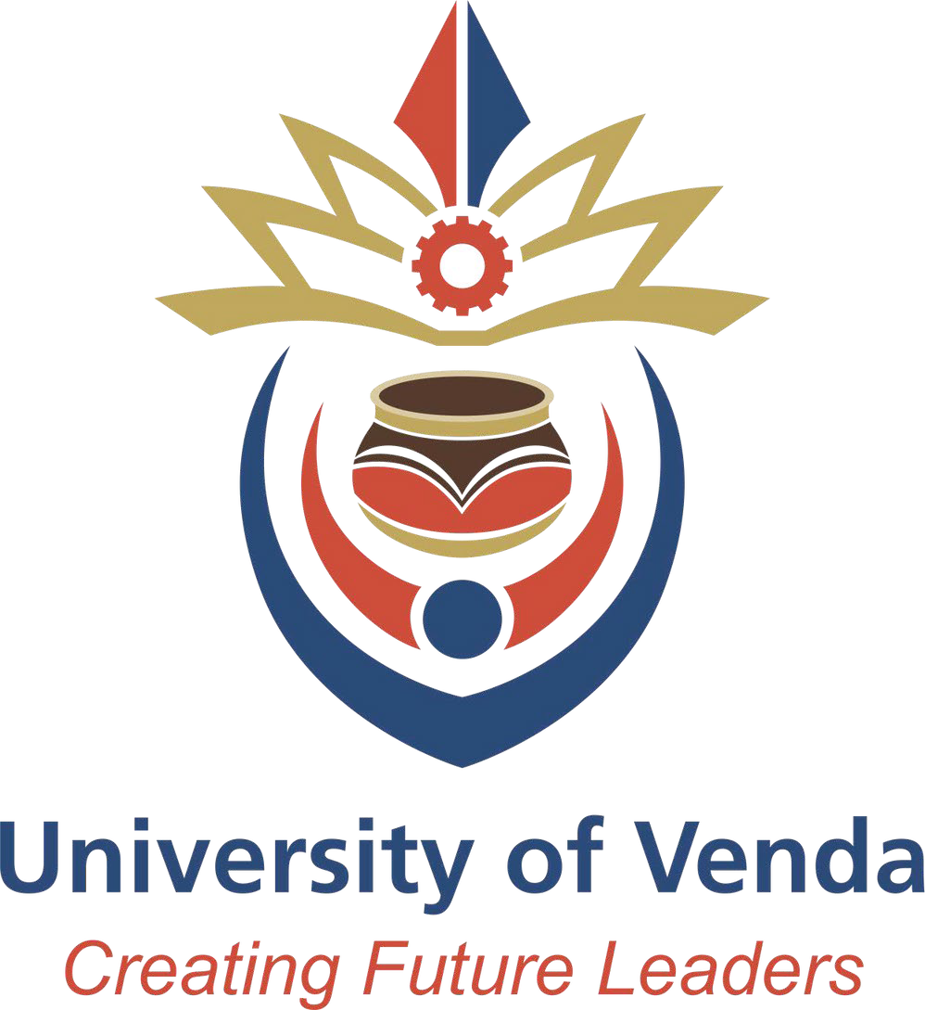

CREATING FUTURE LEADERS

PRE-CONFERENCE WORKSHOPS: 27 October 2025
VENUE: MGB/ 2TEN
08:30-09:00 | Tea and Registration
09:00-09:20 | Welcome Address | SAAIR President
PRE-CONFERENCE WORKSHOPS
09:30-10:30 | WORKSHOP 1  Dr E Atchison  Vice President for Strategic Research  Arkansas State University System  Data literacy and visualization training for institutional leaders and IR professionals with Data Governance Implementation
10:30-11:00 | MORNING TEA BREAK
11:00-13:00 | PRE-CONFERENCE WORKSHOPS Continued
11:00-13:00 | WORKSHOP 1 (continued)

13:00-14:00 | LUNCH BREAK
14:00-15:30 | WORKSHOP 2  Prof R Miller  Former Head of Foresight and Future Literacy at UNESCO. Senior Fellow at: Ecole des Ponts Business School (France); U. New Brunswick (Canada); NIFU (Norway); U. Witwatersrand (South Africa); Future Africa at U. Pretoria (South Africa), and East China Normal U. (China).  The Future of Excellence In 2060: mini-futures literacy lab | WORKSHOP 3  Innocent Mamvura and Sibusiso Msomi  Agentic AI and Autonomous Agents in Higher Education: From Concept to Campus Implementation
15:30-15:45 | AFTERNOON TEA BREAK
15:45-17:15 | WORKSHOP 2 (continued) | WORKSHOP 3 (continued)
17:15 | END OF DAY  Social Event: “Tropical Sunset Soirée” @ MGB/2TEN

Day 1: 28 October 2025
Venue: Kalahari Waterfront, Thohoyandou, 0950, Limpopo Province,
08:00-09:00 | Tea and Registration
Plenary Session: Nkhelebeni Conference Centre
Chair: SAAIR President
09:00-09:20 | Welcome Remarks | Conference Chairperson:  Dr Patience Mativandlela
09:20-09:40 | Opening Address by SAAIR President | SAAIR President: Ms Elizabeth Booi
09:40-09:45 | Introduction of Keynote Speaker | SAAIR EXCO: Dr Hossein Karakani Masoumi
09:45-10:30 | Keynote Address:  The Trouble with Solutionism: futures literacy and the value of ‘not-knowing’ | Prof R Miller  Former Head of Foresight and Future Literacy at UNESCO. Senior Fellow at: Ecole des Ponts Business School (France); U. New Brunswick (Canada); NIFU (Norway); U. Witwatersrand (South Africa); Future Africa at U. Pretoria (South Africa), and East China Normal U. (China).
10:30-10:45 | Question and Answer Session
10:45-11:00 | Sponsor Presentation | Quantum Education Systems (Platinum partnership)
11:00-11:30 | Morning Tea Break

Plenary Session: Nkhelebeni Conference Centre
Chair: Sannah Patience Mativandlela
11:30-12:15 | Keynote Address  Combined Assurance in the Digital Era: Leveraging Technology and Data Governance for Effective Strategic Oversight. | Dr E Mabote  Acting Deputy Vice-Chancellor: Digital Transformation  Tshwane University of Technology
12:15-12:45 | Panel Discussion: Professionalising Institutional Research and Related Fields through a Formal Qualification | Dr Emily Mabote (Tshwane University of Technology)  Dr Remy Nnadozie (Rhodes University)  Dr Nandarani Maistry (University of Johannesburg)  Dr Mxolisi Masango (Cape Peninsula University of Technology)  Glen Barnes (IDSC)  Papama Somgede (University of Pretoria)
12:45-13:00 | Question and Answer Session
13:00-14:00 | Lunch Break
Plenary Session: Nkhelebeni Conference Centre
Chair: Hossein Masoumi Karakani
14:00-14:45 | Keynote Address:  Funding the Future: Advancing sustainability and stability for higher education systems: policy, planning, data and knowledge. | Prof T Lewin  Associate Professor  University of Johannesburg
14:45-15:00 | Question and Answer Session
15:00-15:30 | Tea Break
Parallel Sessions  15:30-16:00 | Parallel Sessions
Parallel Sessions  15:30-16:00 | Venue: Buruvhutsi  Chair: Lufuno Netshifhefhe | Venue: Zwiapenga  Chair: Tebogo Makhambeni | Venue: Mavhevhe  Chair: Zolani Fana
Parallel Sessions  15:30-16:00 | Session 1.1  Sub-theme: Bridging the Skills Gap: Empowering workforce development through human-centred AI and future-focused higher education. | Session 1.2  Sub-theme: Ensuring Excellence:  Enhancing quality assurance frameworks to support transformative, sustainable higher education systems. | Session 1.3  Sub-theme: From Insight to Impact: Strengthening strategic governance through data-driven decision-making and emerging technologies.
15:30-16:00 | 1: Presenter/s: Kabiru Ishola Genty and Sulaiman Olusegun Atiku  Title: Human Resource Analytics and Higher Education Institution Efficiency: An Empirical Evidence from Nigeria | 2: Presenter/s: Madoda Makola  Title: Ensuring Excellence through Integrated Institutional  Governance: Lessons from the Integrated Planning, Resource  Allocation and Quality Management (IPRAQuaM) Framework in  South African HEIs | 3: Presenter/s: Elizabeth Booi and Ronald Arendse  Title: Advancing Student Success Through Data-Informed Reform of Gateway Quantitative Modules
16:00 | Day End and UNIVEN Campus Tour

Day 2: 29 October 2025
Venue: Kalahari Waterfront, Thohoyandou, 0950, Limpopo Province
08:00-09:00 | Tea and Registration
Plenary Session: Nkhelebeni Conference Centre
Chair: Benjamin Ntshabele
09:00-09:20 | Welcome Remarks Conference Chairperson | Conference Chairperson: Dr Patience Mativhandlela
09:20-09:30 | Welcome and introduction of the Vice Chancellor and Principal of the University of Venda | Dr TV Dzaga  Director Marketing, Branding and Communication at the University of Venda
09:30-09:55 | Welcome Address | Prof NB Nthambeleni  Vice Chancellor and Principal of the University of Venda
09:55-10:40 | Keynote Address  Excellence in Action: Leveraging Operational Intelligence and Research to Enhance Student and Institutional Outcomes | Dr E Atchison  Vice President for Strategic Research  Arkansas State University System
10:40-10:50 | Question and Answer Session
10:50-11:00 | Sponsor Presentation | IDSC
11:00-11:30 | Morning Tea Break and Conference Photograph Session

Parallel Sessions  11:30-13:00 | Venue: Buruvhutsi  Chair: Innocent Mamvura | Venue: Zwiapenga  Chair: Lufuno Netshifhefhe | Venue: Mavhevhe  Chair: Tebogo Makhambeni
Parallel Sessions  11:30-13:00 | Session 2.1  Sub-theme: Bridging the Skills Gap: Empowering workforce development through human-centred AI and future-focused higher education. | Session 2.2  Sub-theme: Ensuring Excellence:  Enhancing quality assurance frameworks to support transformative, sustainable higher education systems. | Session 2.3  Sub-theme: From Insight to Impact: Strengthening strategic governance through data-driven decision-making and emerging technologies.
11:30-12:00 | 4: Presenter/s: Kirsten Lucas and Pieter Nagel  Title: Learning from the Dragon: Chinese Higher Education Insights for South Africa | 5: Presenter/s: Juan-Claude Lemmens  Title: Curriculum Analytics to Inform Curriculum Quality and Programme Reviews | 6: Presenter/s: Anri Wheeler  Title: Leveraging longitudinal Graduate data for strategic governance: A case study from a South African higher education institution
12:00-12:30 | 7: Presenter/s: Hossein Masoumi Karakani and Munienge Mbodila  Title: Strategic Workforce Planning in South African Higher Education: A Data-Driven Framework for Sustainable Institutional Development and NDP 2030 Alignment | 8: Presenter/s: Darlington Mutakwa, Nandarani Maistry, Takalani Muloiwa-Klenam and Thato Bhembe  Title: A deep dive into male participation in higher education | 9: Presenter/s: Mari Ford and Darlington Chigori  Title: Tracing Graduate Pathways: Insights from a Graduate Destination Study at the University of Fort Hare
12:30-13:00 | 10: Presenter/s: Munienge Munienge, Louis Mapatagane, Anele Bangani, Nocwaka Pangwa and Xolisa Mabunu  Title: Students’ Perceptions on the Support Received from Academic Advisors: A Reflection on the Students of Interest Follow up Survey | 11: Presenter/s: Olushola Olatunji  Title: Quality Assurance in South African Higher Education: A Transformative Framework for the 21st Century | 12: Presenter/s: Alugumi Ndou and Mpeiwa Thanyani  Title: Role of library in enhancing student success in historical disadvantaged university
13:00-14:00 | Lunch Break

 | Parallel Sessions
Parallel Sessions  14:00-15:30 | Venue: Buruvhutsi  Chair: Benjamin Ntshabele | Venue: Zwiapenga  Chair: Munienge Mbodila | Venue: Mavhevhe  Chair: Valentine Maroga
Parallel Sessions  14:00-15:30 | Session 2.4  Sub-theme: Funding the Future: Advancing sustainable financial  planning and resource optimisation in a rapidly evolving  academic landscape. | Session 2.5  Sub-theme: Ensuring Excellence:  Enhancing quality assurance frameworks to support transformative, sustainable higher education systems. | Session 2.6  Sub-theme: From Insight to Impact: Strengthening strategic governance through data-driven decision-making and emerging technologies.
14:00-14:30 | 13: Presenter/s: Cecilia Frans and Morongwa Selolo  Title: Critical Analysis of University Funding for Postgraduate Programs | 14: Presenter/s: Anri Wheeler and Laurika Wiese  Title: Collaborative quality enhancement: A narrative analysis of the impact of a Quality Exchange Forum on quality in South African Higher Education | 15: Presenter/s: Liberty Takudzwa Nyete  Title: Predictive Analytics in Student Support: Building a Sustainable Ecosystem at a Higher Institution.
14:30-15:00 | 16: Presenter/s: Mbongi Ndlovu and Glen Barnes  Title: Towards resource optimisation - Differentiating the financial contributions of academic units | 17: Presenter/s: Sulaiman Atiku and Himeesora Kaimu  Title: Exploring the Plausible Pathways toward Inclusive and Equitable Education 5.0: An Appreciative Inquiry for Quality Higher Education in Namibia | 18: Presenter/s: Hossein Masoumi Karakani, Mxolisi Masango and Takalani Muloiwa-Klenam  Title: From Entry to Exit: A Data-Driven Framework for a Student-Centered Recommender System within the South African Higher Education Sector
15:00-15:30 | Afternoon Tea Break

 | Parallel Sessions
Parallel Sessions  15:30-16:30 | Venue: Buruvhutsi  Chair: Benjamin Ntshabele | Venue: Zwiapenga  Chair: Zolani Fana | Venue: Mavhevhe  Chair: Hossein Masoumi Karakani
Parallel Sessions  15:30-16:30 | Session 2.7  Sub-theme: Funding the Future: Advancing sustainable financial  planning and resource optimisation in a rapidly evolving  academic landscape. | Session 2.8  Sub-theme: Global and Continental Commitments:  Advancing higher education’s role in achieving the UN 2030 SDGs and Africa’s Agenda 2063 aspirations. | Session 2.9  Sub-theme: From Insight to Impact: Strengthening strategic governance through data-driven decision-making and emerging technologies.
15:30-16:00 | 19: Presenter/s: Thembelihle Luthuli  Title: Policy Intentions to Practice: Analysing Planned Funding Allocations in South African Higher Education (2019–2023) | 20: Presenter/s: Valentine Maroga and Njabulo Ngobese  Title: Aligning Research Funding Strategies with National Development Goals: A UoT Perspective | 21: Presenter/s: Herman Janse van Vuuren  Title: Module Review Process to Enhance Success in High Impact Modules
16:00-16:30 | 22: Presenter/s: Darlington Mutakwa  Title: Student Debt – Can We Resolve It or Learn to Live With It? | 23: Presenter/s: Siphelo Mapolisa, Dorah Queen Sekhosana and Tshegofatso Kgomo  Title: Exploring Student Safety Experiences in ODeL: Challenges and Best Practices Report | 24: Presenter/s: Anele Bangani and Munienge Mbodila  Title: The 'Matriculation Gap' and Students’ University Success: A case student of a South African Higher Education Institution
16:30 | End of Day 2
18:00-23:00 | Gala Dinner  Dress Code: Formal/Black Tie @Porche-Villa Hotel and Conference Centre

Day 3: 30 October 2025
Venue: Kalahari Waterfront, Thohoyandou, 0950, Limpopo Province
08:00-09:00 | Registration and Tea
Plenary Session: Nkhelebeni Conference Centre
Chair: Hossein Masoumi Karakani
09:00-09:10 | Welcome Remarks and Reflections of Day 1 and 2 |  | SAAIR EXCO: Dr Mbodila Munienge
09:10-09:40 | Keynote:  From Crisis to Capability: Building AI That Works Where It Matters Most for Learning |  | Prof M Mosia  Vice-Dean: Teaching and Learning  University of the Free State
09:40-10:00 | Demonstration:  Platform Walkthrough: Making Expert Mathematics Teaching Accessible at Scale through our AI-powered platform. |  | Prof M Mosia  Vice-Dean: Teaching and Learning  University of the Free State
10:00-10:30 | Question and Answer Session
10:30-11:00 | Morning Tea Break
Parallel Sessions  11:00-11:30 | Parallel Sessions
Parallel Sessions  11:00-11:30 | Venue: Buruvhutsi  Chair: Vhutshilo Nekhubvi | Venue: Zwiapenga  Chair: Innocent Mamvura |  | Venue: Mavhevhe  Chair: Elizabeth Booi
Parallel Sessions  11:00-11:30 | Session 3.1  Sub-theme: Global and Continental Commitments: Advancing higher  education’s role in achieving the UN 2030 SDGs and Africa’s  Agenda 2063 aspirations | Session 3.2  Sub-theme: Bridging the Skills Gap: Empowering workforce development through human-centred AI and future-focused higher education. |  | Session 3.3  Sub-theme: Funding the Future: Advancing sustainable financial planning and resource optimisation in a rapidly evolving academic landscape.
11:00-11:30 | 25: Presenter/s: Alugumi Ndou and Jerry Mahlangu  Title: Information literacy instruction as a student-success ecosystem at a South-African university | 26: Presenter/s: Hloniphile Cleopatra Zwane, Thembisile Alice Ndimande and Victor Halalisani Mlambo  Title: Artificial Intelligence as a catalyst to Enhance Teaching, Learning, and Decision-Making in Higher Education: A South African Perspective |  | 27: Presenter/s: Remy Nnadozie  Title: The Impact of Higher Education Sector Changes on Mathematical Parameters of South Africa's Funding Formula for Public Universities
11:30-12:00 | 28: Presenter/s: Loquitur Maka  Title: Ready or Not? Unpacking Digital Divides in First-Year Students’ University Preparedness | 29: Presenter/s: Azwy Christopher Tshivhase and Denise Rosemary Nicholson  Title: Transforming Higher Education Through AI Innovation: The Role of the University of South Africa (Comprehensive Open Distance E-Learning Institution). |  | 30: Presenter/s: Valentine Maroga and Modjadji Mtsweni  Title: The Role of Research Outputs in Attracting External Funding and Enhancing Reputation
12:00-13:30 | Plenary Session: Main Venue  SAAIR AGM |  | SAAIR EXCO
13:30-14:30 | Lunch Break
Parallel Sessions  14:30-15:00 | Parallel Sessions
Parallel Sessions  14:30-15:00 | Venue: Buruvhutsi  Chair: Elizabeth Booi | Venue: Zwiapenga  Chair: Benjamin Ntshabele |  | Venue: Mavhevhe  Chair: Valentine Maroga
Parallel Sessions  14:30-15:00 | Session 3.4  Sub-theme: Ensuring Excellence:  Enhancing quality assurance frameworks to support transformative, sustainable higher education systems. | Session 3.5  Sub-theme: Ensuring Excellence:  Enhancing quality assurance frameworks to support transformative, sustainable higher education systems. |  | Session 3.6  Sub-theme: From Insight to Impact: Strengthening strategic governance through data-driven decision-making and emerging technologies.
14:30-15:00 | 31: Presenter/s: Vakele Nobongoza and Somarie Hotlzhausen  Title: Towards Excellence in Navigating Institutional Pressures and Contingencies: a Neo-Institutional and Contingency Analysis of Internal Quality Assurance in South African Comprehensive Universities | 32: Presenter/s: Hossein Masoumi Karakani and Ashton Maherry  Title: From Compliance to Collaboration: Leveraging Institutional Audit Outcomes for Strategic Improvement in South African Higher Education |  | 36: Presenter/s: Innocent Mamvura and Lerato Makuapane  Title: Falling Behind: A Mixed-Methods Analysis of Male Student Success in South African Universities
15:00-18:00 | Community Outreach: Tshakhuma Fruit & Vegetable Market

Day 4: 31 October 2025
Venue: Kalahari Waterfront, Thohoyandou, 0950, Limpopo Province
08:00-09:00 | Registration and Tea
Parallel Sessions  09:00-10:00 | Parallel Sessions
Parallel Sessions  09:00-10:00 | Venue: Buruvhutsi  Chair: Ashton Maherry | Venue: Zwiapenga  Chair: Benjamin Ntshabele
Parallel Sessions  09:00-10:00 | Session 4.1  Sub-theme: Bridging the Skills Gap: Empowering workforce development through human-centred AI and future-focused higher education. | Session 4.2  Sub-theme: Ensuring Excellence:  Enhancing quality assurance frameworks to support transformative, sustainable higher education systems.
09:00-09:30 | 34: Presenter/s: Elizabeth Booi  Title: Building a Data Culture: Advancing Digital and Data Literacy | 35: Presenter/s: Thato Mokoma  Title: Advancing Equity Through Analytics: The Role of Eigenvalues in Strengthening Standardisation in Education
09:30-10:00 | 36: Presenter/s: Murendeni Mukwevho and Kevin Silomo  Title: Empowering workforce development through human-centric Ai | Session 4.3  Sub-theme: From Insight to Impact: Strengthening strategic governance through data-driven decision-making and emerging technologies.
09:30-10:00 |  | 37: Presenter/s: Lerato Makuapane and Fezile Wagner  Title: Designed with students, for students: validating the mental health assessment tools used in the Fit Minds Survey through student voice.
10:00-10:30 | Morning Tea Break

Parallel Sessions  10:30-11:30 | Parallel Sessions – Panel Discussions
Parallel Sessions  10:30-11:30 | Venue: Buruvhutsi  Chair: Sannah Patience Mativandlela | Venue: Zwiapeng  Chair: Benjamin Ntshabele
Parallel Sessions  10:30-11:30 | Session 4.5  Sub-theme: From Insight to Impact: Strengthening strategic governance through data-driven decision-making and emerging technologies. | Session 4.6  Sub-theme: Sub-theme: From Insight to Impact: Strengthening strategic governance through data-driven decision-making and emerging technologies.
10:30-11:30 | Panel Discussion Title: AI for Institutional Operational Excellence and Strategic Foresight: Opportunities, Risks, and Real-World Practice  Panellist /s: Innocent Mamvura (University of the Witwatersrand)  Dr Eric Atchison (Arkansas State University System)  Dr Mbodila Munienge (Walter Sisulu University)  Prof Sulaiman Olusegun Atiku (Namibia University of Science and Technology)  Prabashnee Kisten (Durban University of Technology) | Panel Discuss Title: I Am: Embedding the Student Voice in Higher Education through Siyaphumelela  Panellist /s: Panellists: Ashton Maherry (Saide)  Simphiwe Kunene (Varsity College)  Bradley Gawie (Central University of Technology, Free State)
Plenary Session: Nkhelebeni Conference Centre
Chair: Hossein Masoumi Karakani
11:35-12:35 | Panel Discussion: SAAIR Scholars | Panellists: Luna August (University of Cape Town)  Lerato Makuapane (University of the Witwatersrand)  Lebohang Mojapelo (University of Pretoria)  Zanele Maloyi (University of South Africa)
12:35-12:45 | Conference Closure | SAAIR President: Ms Elizabeth Booi
12:45 | Lunch and Departure

Sponsors




