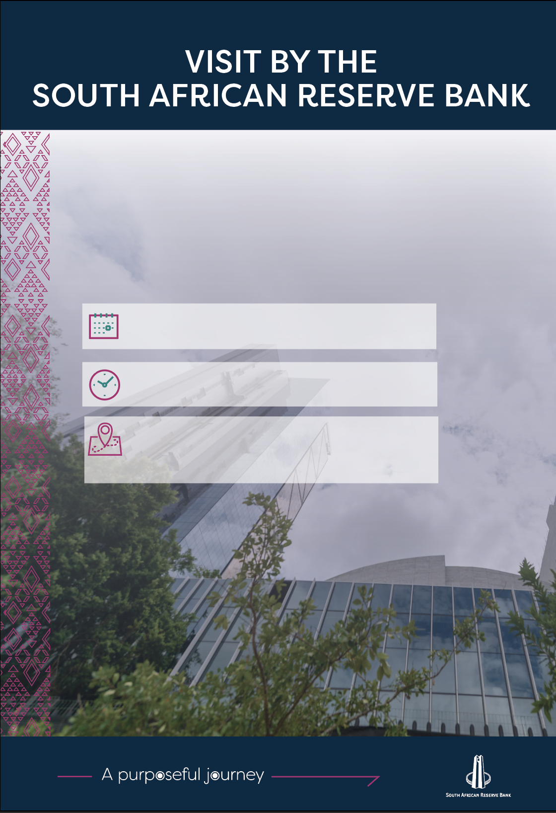
University of Venda
D1 Lecture Hall
University Road
Thohoyandou
10:30-12:00

Thursday, 19 March 2026
 |  | 
 | P O Box 427 Pretoria 0001 South Africa
 | 370 Helen Joseph Street Pretoria 0002
 | +27 12 313 3911 / 0861 12 7272
 | www.resbank.co.za
File ref. no.11/32 |  | Executive Management Department

A visit to the University of Venda
Thursday, 19 March 2026

Programme: Programe Director Dr T Munzhelele
Time | Topic
10:00 | The South African Reserve Bank (SARB) delegation arrives at the University of Venda, University Road, Thohoyandou, via the new Muledane Gate, where they will find Mr Mudzanani waiting for them. He will lead them to the parking space at the School of Environmental Sciences building.
10:05 | The SARB delegation is led to the lecture venue, D1 Lecture Hall
10:15 | Delegation's arrival at the venue
10:20 | Welcome by Mr FR Sikhitha and introduces HOD
10:25-10:35 | Opening remarks:  Prof. Gift Dafuleya – HOD: Economics Department
10:35–11:30 | A presentation on the mandate followed by a Q&A session
11:30–11:58 | A presentation on career opportunities at the SARB followed by a Q&A session
11:58-12:00 | Vote of Thanks- Dr Jean Mubenga
12:00 | The lecture ends

SARB delegation
Dr Nkhetheni Nesengani | Lead Economist  Economic Research Department
Ms Pamela Vorster | Senior Economist  Economic Research Department
Mr Pabalelo Mosoma | Junior Economist  Economic Research Department
Ms Senelisiwe Mntambo | Learning and Development Consultant  SARB Academy

SARB contact
Ms Khayalami Dhlamini | Public Outreach Officer  012 313 4463 / 078 131 2084/ 073 366 8095 (WhatsApp)

Univen contact
Mr Ronewa Mudzanani | Community Engagement Coordinator  015 962 9265/ 076 187 1336 (Whatsap 0649089889)

